

**YourBank**

**Customer Relationship Management**

**Software Requirement Specifications**

**Project Code: CRM-Online**

**Document Code: CRM_SRS_v1.0.1**

HCMC, Apr-2014



**Record of change**

*A - Added M - Modified D - Deleted

|  |  |  |  |  |
| --- | --- | --- | --- | --- |
| Effective Date | Changed Items | A* M, D | Change Description | New Version |
| Jan 13, 2010 |  | A | The first version | 1.0 |
| Jan 04, 2014 | 5. Nonfunctional requirement | A | Add more requirements | 1.0.1 |
|  |  |  |  |  |
|  |  |  |  |  |
|  |  |  |  |  |
|  |  |  |  |  |
|  |  |  |  |  |
|  |  |  |  |  |
|  |  |  |  |  |
|  |  |  |  |  |
|  |  |  |  |  |
|  |  |  |  |  |
|  |  |  |  |  |
|  |  |  |  |  |
|  |  |  |  |  |
|  |  |  |  |  |
|  |  |  |  |  |
|  |  |  |  |  |
|  |  |  |  |  |
|  |  |  |  |  |
|  |  |  |  |  |
|  |  |  |  |  |

**SIGNATURE PAGE**

AUTHOR: Name: FPT Software Signature:

Title: Date:

REVIEWERS: Name: ___________ Signature:

Title: Date:

APPROVAL: Name: ___________ Signature:

Title: Date:

Name: Signature:

Title: Date:

Table of Contents

Contents

**YourBank** 1

**Customer Relationship Management** 1

**Software Requirement Specifications** 1

**Project Code: CRM-Online** 1

**Document Code: CRM_SRS_v1.0.1** 1

**Record of change** 2

**SIGNATURE PAGE** 3

Table of Contents 4

1.1. Purpose 8

1.2. Definitions, Acronyms, and Abbreviations 8

1.3. References 8

2. High Level Requirements 9

2.1. Product Perspective 9

2.2. Actors and Use Cases Descriptions 10

2.2.1. Diagram 10

2.2.2. Actors Description 15

2.2.3. Use Cases Description 15

2.2.4. Use Case & Actor mapping 16

2.3. Operating Environment 18

2.4. Assumption and Dependencies 18

3. Functional Requirements 18

3.1. Module 01 18

3.1.1. UC01: Login 18

3.1.2. UC02: List users in a division 19

3.1.3. UC03: Search users 20

3.1.4. UC04: View details user 20

3.1.5. UC05: Add new user 21

3.1.6. UC06: Edit user 22

3.1.7. UC07: Delete user 23

3.1.8. UC08: List devisions 24

3.1.9. UC09: View detail devison 24

3.1.10. UC10: Add new devision 25

3.1.11. UC11: Edit devision 26

3.1.12. UC12: Delete devision 26

3.2. Module 02 27

3.2.1. UC13: Search customers 27

3.2.2. UC14: View detail customer 28

3.2.3. UC15: View customer histories 28

3.2.4. UC16: Add new customer 29

3.2.5. UC17: Edit customer 30

3.2.6. UC18: Delete customer 31

3.2.7. UC19: List used services 31

3.2.8. UC20: Add new used services 32

3.2.9. UC21: Update used services 33

3.2.10. UC22: Approve change 33

3.2.11. UC23: Nhập dữ liệu - Tình hinh SXLD 34

3.2.12. UC24: Nhập dữ liệu – Quan hệ với các tổ chức tín dụng 35

3.2.13. UC25: Nhập dữ liệu – Lịch sử tiếp xúc 36

3.2.14. UC26: Edit dữ liệu - Tình hinh SXLD 36

3.2.15. UC27: Edit dữ liệu – Quan hệ với các tổ chức tín dụng 37

3.2.16. UC28: Edit dữ liệu – Lịch sử tiếp xúc 38

3.2.17. UC29: Details View – Tình hình SXKD 39

3.2.18. UC30: Details View – Quan hệ với các tổ chức tín dụng 40

3.2.19. UC31: Details View – Lịch sử tiếp xúc 41

3.2.20. UC32: Duyệt TXKH – Approve 41

3.2.21. UC33: Duyệt TXKH – Reject 42

3.2.22. UC34: Duyệt TXKH – Cancel 43

3.2.23. UC35: Xóa – Quan hệ với các tổ chức tín dụng 43

3.2.24. UC36: Xóa – Lịch sử tiếp xúc 44

3.3. Module 03 45

3.3.1. UC37: Báo cáo theo CIF 45

3.3.2. UC38: Báo cáo theo ĐVKD 46

3.3.3. UC39: Báo cáo toàn bank 46

3.3.4. UC40: Lấy thông tin từ TPB 47

3.3.5. UC41: Validation user AD 48

3.3.6. UC42: Check user AD 49

3.3.7. UC43: Define categories 49

3.3.8. UC44: 50

4. Mockup Screens 51

4.1. SC01: Login 51

4.2. SC02: List users in a devision 51

4.3. SC03: Search users 53

4.4. SC04: View details user 53

4.5. SC05: Add new user 54

4.6. SC06: Edit user 54

4.7. SC07: Delete user 55

4.8. SC08: List devisions 55

4.9. SC09: View detail devison 56

4.10. SC10: Add new devision 57

4.11. SC11: Edit devision 57

4.12. SC12: Delete devision 58

4.13. SC13: Search customers 58

4.14. SC14: View detail customer 59

4.15. SC15: View customer histories 59

4.16. SC16: Add new customer 60

4.17. SC17: Edit customer 60

4.18. SC18: Delete customer 62

4.19. SC19: List used services 63

4.20. SC20: Add new used services 63

4.21. SC21: Update used services 64

4.22. SC22: Approve change 65

4.23. SC23: Nhập dữ liệu - Tình hinh SXLD 66

4.24. SC24: Nhập dữ liệu – Quan hệ với các tổ chức tín dụng 67

4.25. SC25: Nhập dữ liệu – Lịch sử tiếp xúc 68

4.26. SC26: Edit dữ liệu - Tình hinh SXLD 69

4.27. SC27: Edit dữ liệu – Quan hệ với các tổ chức tín dụng 70

4.28. SC28: Edit dữ liệu – Lịch sử tiếp xúc 71

4.29. SC29: Details View – Tình hình SXKD 71

4.30. SC30: Details View – Quan hệ với các tổ chức tín dụng 72

4.31. SC31: Details View – Lịch sử tiếp xúc 72

4.32. SC32: Duyệt TXKH – Approve 73

4.33. SC33: Duyệt TXKH – Reject 75

4.34. SC34: Duyệt TXKH – Cancel 77

4.35. SC35: Xóa – Quan hệ với các tổ chức tín dụng 78

4.36. SC36: Xóa – Lịch sử tiếp xúc 78

4.37. SC37: Báo cáo theo CIF 79

4.38. SC38: Báo cáo theo ĐVKD 80

4.39. SC39: Báo cáo toàn bank 81

4.40. SC40: 81

5. Nonfunctional Requirements 81

5.1. Accessibility 81

5.2. Audit-ability 82

5.3. Correctness 82

5.3.1. Accuracy 82

5.3.2. Precision 82

5.4. Interoperability 82

5.5. Maintainability 82

5.6. Performance 83

5.6.1. Capacity 83

5.6.2. Response Time 83

5.6.3. Throughput 83

5.7. Portability 83

5.8. Reliability 83

5.9. Reusability 84

5.10. Robustness 84

5.11. Safety 84

6. System Constraints 84

6.1. Business Rules 84

6.2. Data and Content Constraints 84

6.2.1. Databases 84

6.3. Hardware Constraints 84

6.4. Software Constraints 85

6.4.1. High-Level Languages 85

6.5. Industry Standards 85

6.6. Legal and Regulatory Constraints 85

7. Appendices 86

A. Envisioned Future Enhancements 86

TBD 86

B. Open Issues 86

TBD 86

C. Major TBDs 86

This appendix documents the following major TBDs: 86

D. Assumptions 86

Introduction

## Purpose

This Software Requirements Specification provides a complete description of all the functions and specifications of the CRM project developing Customer Relationship Management System. This document is intended to be used by the members of the project team that will implement and verify the correct functioning of the system.

## Definitions, Acronyms, and Abbreviations

|  |  |  |
| --- | --- | --- |
| **#** | **Abbreviations/Terms** | **Explanation** |
| 1 | SRS | Software Requirement Specification |
| 2 | BR | Business Rule |
| 3 | SC | Screen |
| 4 | UC | Use Case |
| 5 | CRUD | Create/Read/Update/Delete a record in database |

Table 1: Abbreviations & Terminologies

## References

|  |  |  |
| --- | --- | --- |
| **#** | **Name** | **Description** |
|  |  |  |

Table 2: Reference

# High Level Requirements

## Product Perspective



This application is integrated into eHTi which can also operate independently, shall offer a unified place for the MHA officers to find, communicate with, manage people and their permissions, including support for custom fields such as area of focus, specialty, language proficiency etc.

## Actors and Use Cases Descriptions



### Diagram

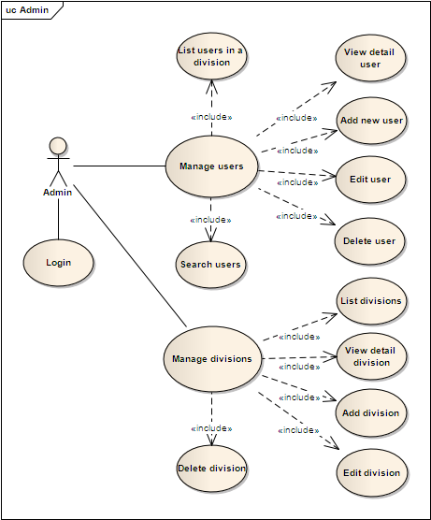

**Diagram 01 – Admin roles**

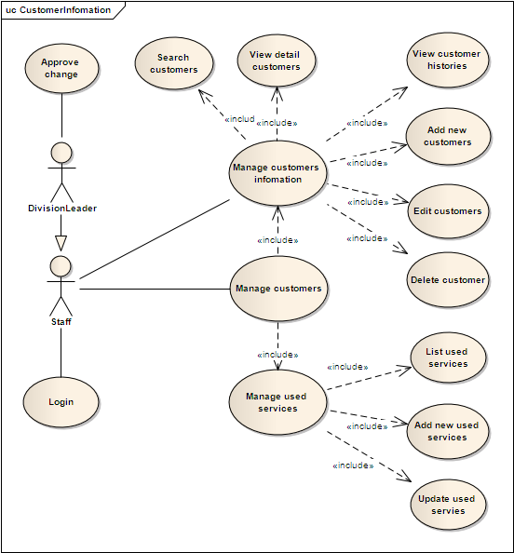

**Diagram 02 – Quản lý thông tin khách hàng**

Note: ESD admins can access to ALL functions

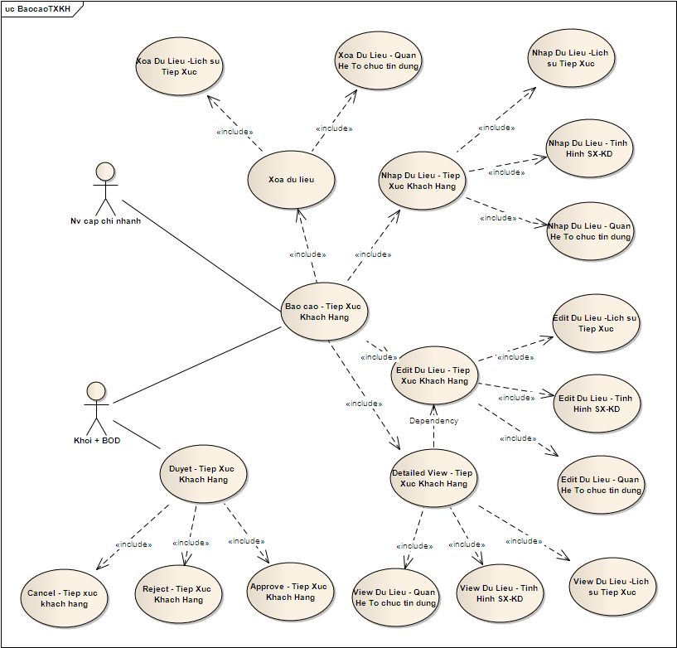

**Diagram 03 – Quản lý báo cáo tiếp xúc KH**

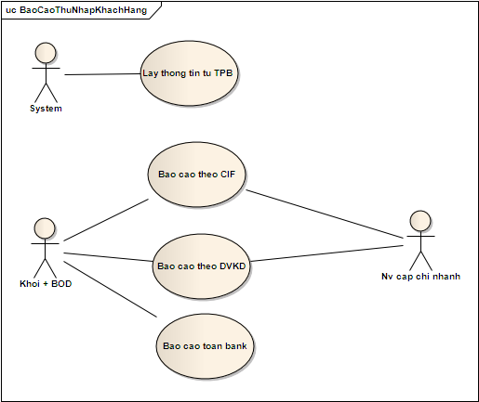

**Diagram 04 – Quản lý báo thu nhập KH**

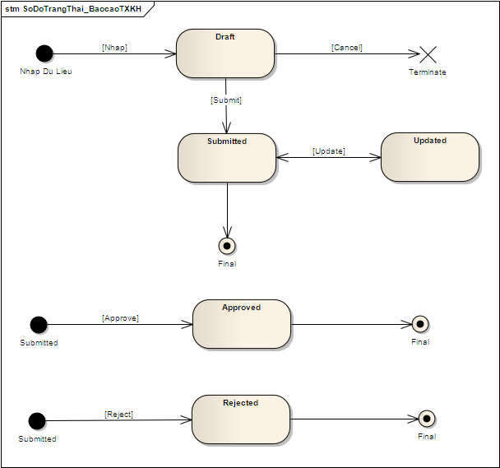

**Diagram 05 – Sơ đồ trạng thái báo cáo TXKH**

### Actors Description

|  |  |  |
| --- | --- | --- |
| **#** | **Actor Name** | **Definition & Interests** |
| 1 | Admin |  |
| 2 | Division Leader |  |
| 3 | Staff |  |
| 4 | BOD |  |
| 5 | System |  |

### Use Cases Description

|  |  |  |  |
| --- | --- | --- | --- |
| **#** | **Code** | **Name** | **Brief Description** |
| 1 | UC01 | Login | Cho phép actor đăng nhập vào hệ thống |
| 2 | UC41 | Validation user AD | Cho phép xác định quyền truy cập so với hệ thống AD |
| 3 | UC02 | List users in a devision | Cho phép actor view toàn bộ users trong hệ thống |
| 4 | UC03 | Search users | Cho phép actor tìm kiếm users trong hệ thống |
| 5 | UC04 | View details user | Cho phép actor view chi tiết một user |
| 6 | UC05 | Add new user | Cho phép actor thêm mới một user |
| 7 | UC42 | Check user AD | Cho phép xác định User so với hệ thống AD |
| 8 | UC06 | Edit user | Cho phép actor cập nhật thông tin một user |
| 9 | UC07 | Delete user | Cho phép actor xóa một user |
| 10 | UC08 | List devisions | Cho phép actor view toàn bộ phòng ban/chi nhánh |
| 11 | UC09 | View detail devison | Cho phép actor view chi tiết phòng ban/chi nhánh |
| 12 | UC10 | Add new devision | Cho phép actor thêm mới một phòng ban/chi nhánh |
| 13 | UC11 | Edit devision | Cho phép actor cập nhật thông tin phòng ban/chi nhánh |
| 14 | UC12 | Delete devision | Cho phép actor xóa phòng ban/chi nhánh |
| 15 | UC40 | Lấy thông tin từ TPB | Hệ thống tự động lấy thông tin từ TPB phục vụ cho việc kết xuất báo cáo |
| 16 | UC43 | Define categories | Cho phép định nghĩa, mô tả danh mục như các trạng thái, role id.. |
| 17 | UC44 |  |  |
|  | | | |
| 19 | UC13 | Search customers | Cho phép actor tìm kiếm khách hàng |
| 20 | UC14 | View detail customer | Cho phép actor view chi tiết thông tin một khách hàng |
| 21 | UC15 | View customer histories | Cho phép actor view chi tiết lịch sử cập nhật thông tin của một khách hàng |
| 22 | UC16 | Add new customer | Cho phép actor thêm mới một khách hàng |
| 23 | UC17 | Edit customer | Cho phép actor cập nhật thông tin một khách hàng |
| 24 | UC18 | Delete customer | Cho phép actor xóa một khách hàng |
| 25 | UC19 | List used services | Cho phép actor view thông tin dịch vụ khách hàng đang sử dụng |
| 26 | UC20 | Add new used services | Cho phép actor thêm mới dịch vụ khách hàng sử dụng |
| 27 | UC21 | Update used services | Cho phép actor cập nhật dịch vụ khách hàng sử dụng |
| 28 | UC22 | Approve change | Cho phép actor approve submit thông tin khách hàng |
| 29 | UC23 | Nhập dữ liệu - Tình hinh SXLD | Cho phép actor nhập thông tin tình hình SXKD của khách hàng |
| 30 | UC24 | Nhập dữ liệu – Quan hệ với các tổ chức tín dụng | Cho phép actor nhập thông tin quan hệ với các tổ chức tín dụng của khách hàng |
| 31 | UC25 | Nhập dữ liệu – Lịch sử tiếp xúc | Cho phép actor nhập thông tin lịch sử tiếp xúc khách hàng |
| 32 | UC26 | Edit dữ liệu - Tình hinh SXLD | Cho phép actor cập nhật thông tin tình hình SXKD của khách hàng |
| 33 | UC27 | Edit dữ liệu – Quan hệ với các tổ chức tín dụng | Cho phép actor cập nhật thông tin quan hệ với các tổ chức tín dụng của khách hàng |
| 34 | UC28 | Edit dữ liệu – Lịch sử tiếp xúc | Cho phép actor cập nhật thông tin lịch sử tiếp xúc khách hàng |
| 35 | UC29 | Details View – Tình hình SXKD | Cho phép actor view chi tiết thông tin tình hình SXKD của khách hàng |
| 36 | UC30 | Details View – Quan hệ với các tổ chức tín dụng | Cho phép actor view chi tiết thông tin quan hệ với các tổ chức tín dụng của khách hàng |
| 37 | UC31 | Details View – Lịch sử tiếp xúc | Cho phép actor view chi tiết lịch sử tiếp xúc khách hàng |
| 38 | UC32 | Duyệt TXKH – Approve | Cho phép actor approve submit báo cáo TXKH |
| 39 | UC33 | Duyệt TXKH – Reject | Cho phép actor reject submit báo cáo TXKH |
| 40 | UC34 | Duyệt TXKH – Cancel | Cho phép actor cancel submit báo cáo TXKH |
| 41 | UC35 | Xóa – Quan hệ với các tổ chức tín dụng | Cho phép actor xóa thông tin quan hệ với các tổ chức tín dụng của khách hàng |
| 42 | UC36 | Xóa – Lịch sử tiếp xúc | Cho phép actor xóa lịch sử tiếp xúc khách hàng |
| 43 | UC37 | Báo cáo theo CIF | Cho phép actor kết xuất/view báo cáo theo CIF |
| 44 | UC38 | Báo cáo theo ĐVKD | Cho phép actor kết xuất/view báo cáo theo ĐVKD |
| 45 | UC39 | Báo cáo toàn bank | Cho phép actor kết xuất/view báo cáo toàn bank |

Table 3: Use Case List

### Use Case & Actor mapping

|  |  |  |  |  |  |
| --- | --- | --- | --- | --- | --- |
| **Actor**  **Use Case** | **Admin** | **Devision Leader** | **Staff** | **BOD** | **System** |
| UC01: Login | **x** | **x** | **x** | **x** |  |
|  |  |  |  |  |  |
| UC02: List users in a devision | **x** |  |  |  |  |
| UC03: Search users | **x** |  |  |  |  |
| UC04: View details user | **x** |  |  |  |  |
| UC05: Add new user | **x** |  |  |  |  |
|  |  |  |  |  |  |
| UC06: Edit user | **x** |  |  |  |  |
| UC07: Delete user | **x** |  |  |  |  |
| UC08: List devisions | **x** |  |  |  |  |
| UC09: View detail devison | **x** |  |  |  |  |
| UC10: Add new devision | **x** |  |  |  |  |
| UC11: Edit devision | **x** |  |  |  |  |
| UC12: Delete devision | **x** |  |  |  |  |
| UC13: Search customers |  | **x** | **X** |  |  |
| UC14: View detail customer |  | **x** | **x** |  |  |
| UC15: View customer histories |  | **x** | **x** |  |  |
| UC16: Add new customer |  | **x** | **x** |  |  |
| UC17: Edit customer |  | **x** | **x** |  |  |
| UC18: Delete customer |  | **x** |  |  |  |
| UC19: List used services |  | **x** | **x** |  |  |
| UC20: Add new used services |  | **x** | **x** |  |  |
| UC21: Update used services |  | **x** | **x** |  |  |
| UC22: Approve change |  | **x** |  |  |  |
| UC23: Nhập dữ liệu - Tình hinh SXLD |  | **x** | **x** |  |  |
| UC24: Nhập dữ liệu – Quan hệ với các tổ chức tín dụng |  | **x** | **x** |  |  |
| UC25: Nhập dữ liệu – Lịch sử tiếp xúc |  | **x** | **x** |  |  |
| UC26: Edit dữ liệu - Tình hinh SXLD |  | **x** | **x** |  |  |
| UC27: Edit dữ liệu – Quan hệ với các tổ chức tín dụng |  | **x** | **x** |  |  |
| UC28: Edit dữ liệu – Lịch sử tiếp xúc |  | **x** | **x** |  |  |
| UC29: Details View – Tình hình SXKD |  | **x** | **x** |  |  |
| UC30: Details View – Quan hệ với các tổ chức tín dụng |  | **x** | **x** |  |  |
| UC31: Details View – Lịch sử tiếp xúc |  | **x** | **x** |  |  |
| UC32: Duyệt TXKH – Aprove |  | **x** |  |  |  |
| UC33: Duyệt TXKH – Reject |  | **x** |  |  |  |
| UC34: Duyệt TXKH – Cancel |  | **x** |  |  |  |
| UC35: Xóa – Quan hệ với các tổ chức tín dụng |  | **x** |  |  |  |
| UC36: Xóa – Lịch sử tiếp xúc |  | **x** |  |  |  |
| UC37: Báo cáo theo CIF |  | **x** | **x** | **x** |  |
| UC38: Báo cáo theo ĐVKD |  | **x** |  | **x** |  |
| UC39: Báo cáo toàn bank |  |  |  | **x** |  |
| UC40: Lấy thông tin từ TPB |  |  |  |  | **x** |
| UC41: Validation user AD |  |  |  |  | **x** |
| UC42: Check user AD |  |  |  |  | **x** |
| UC43: Define categories | **x** |  |  |  |  |
| UC44: |  |  |  |  |  |

(*): Anonymous user can see wall of other user profile

## Operating Environment

## Assumption and Dependencies

# Functional Requirements

## Module 01

### UC01: Login

**Use Case Description**

|  |  |  |  |
| --- | --- | --- | --- |
| **Name** | Login | **Code** | UC01 |
| **Description** | Cho phép actor đăng nhập vào hệ thống | | |
| **Actor** | Admin/Devision Leader/Staff/BOD | **Trigger** | Actor bấm nút login |
| **Pre-condition** |  | | |
| **Post condition** | Chuyển tới trang default với role tương ứng | | |

**Activities**

|  |  |  |  |
| --- | --- | --- | --- |
| **Actor** | | **System** | |
| **Main Flow: Login thành công** | | | |
| 1 | Actor nhập tên đăng nhập/mật khẩu và click vào button Login trên trang đăng nhập (SC01). |  |  |
|  |  | 2 | Kiểm tra tên đăng nhập/mật khẩu là chính xác sau đó chuyển tới trang default role tương ứng (SC03, SC02...) |

**Business Rules**

|  |  |  |
| --- | --- | --- |
| **Rule No.** | **Rule** | **Description** |
|  |  |  |

**System Message**

|  |  |
| --- | --- |
| MS01 | “Tên Đăng Nhập và/hoặc Mật Khẩu của bạn không chính xác. Vui lòng kiểm tra và thử lại.”  Message thông báo khi actor nhập sai tên đăng nhập/mật khẩu |

### UC02: List users in a division

**Use Case Description**

|  |  |  |  |
| --- | --- | --- | --- |
| **Name** | List users in a division | **Code** | UC02 |
| **Description** | Cho phép actor view toàn bộ users trong hệ thống | | |
| **Actor** | Admin | **Trigger** | Load trang quản lý users |
| **Pre-condition** | Actor đã đăng nhập vào hệ thống | | |
| **Post condition** | View danh sách toàn bộ users trong hệ thống | | |

**Activities**

|  |  |  |  |
| --- | --- | --- | --- |
| **Actor** | | **System** | |
| **Main Flow: List users in a devision successfully** | | | |
| 1 | Actor click vào sub menu item Quản lý người dùng/Quản lý thông tin |  |  |
|  |  | 2 | Load thông tin toàn bộ users có trong hệ thống, bind date vào gridview và hiển thị lên trang Quản lý thông tin người dùng (SC03). |

**Business Rules**

|  |  |  |
| --- | --- | --- |
| **Rule No.** | **Rule** | **Description** |
| 1 | Hiển thị Gridview | GridView hiển thị đúng dữ liệu, dữ liểu đảm bảo đã encode trước khi hiển thị, đảm bảo không vỡ trang khi dữ liệu quá dài. |
| 2 | Ẩn Gridview | Ẩn Gridview khi không có dữ liệu. |

**System Message**

**N/A**

### UC03: Search users

**Use Case Description**

|  |  |  |  |
| --- | --- | --- | --- |
| **Name** | Search users | **Code** | UC03 |
| **Description** | Cho phép actor tìm kiếm users trong hệ thống | | |
| **Actor** | Admin | **Trigger** | Actor click button **[Search]** trên màn hình quản lý thông tin users |
| **Pre-condition** | Actor đã đăng nhập vào hệ thống | | |
| **Post condition** | View danh sách users tìm thấy với điều kiện tìm kiếm hoặc hiển thị message thông báo nếu không tìm thấy user nào thỏa mãn điều kiện. | | |

**Activities**

|  |  |  |  |
| --- | --- | --- | --- |
| **Actor** | | **System** | |
| **Main Flow: Search users successfully** | | | |
| 1 | Actor nhập/lựa chọn điều kiện tìm kiếm trên màn hình quản lý thông tin users (SC03), click button **[Search]** |  |  |
|  |  | 2 | Select danh sách users tìm thấy trong CSDL với điều kiện tìm kiếm |
|  |  | 3 | Load danh sách users tìm thấy vào gridview và hiển thị lên trang (SC03) |

**Business Rules**

|  |  |  |
| --- | --- | --- |
| **Rule No.** | **Rule** | **Description** |
| 1 | Hiển thị Gridview | GridView hiển thị đúng dữ liệu, dữ liểu đảm bảo đã encode trước khi hiển thị, đảm bảo không vỡ trang khi dữ liệu quá dài. |
| 2 | Ẩn Gridview | Ẩn Gridview khi không có dữ liệu. Hiển thị message thông báo không tìm thấy user thỏa mãn. |

**System Message**

|  |  |
| --- | --- |
| MS01 | “Hệ thống không tìm thấy thông tin khách hàng trên. Vui long thử lại.”  Message thông báo khi hệ thống không tìm thấy user thỏa mãn điều kiện tìm kiếm của actor |

### UC04: View details user

**Use Case Description**

|  |  |  |  |
| --- | --- | --- | --- |
| **Name** | View details user | **Code** | UC04 |
| **Description** | Cho phép actor view chi tiết một user | | |
| **Actor** | Admin | **Trigger** | Actor click link ***Chi tiết*** của một user trên gridview |
| **Pre-condition** | Actor đã đăng nhập vào hệ thống. | | |
| **Post condition** | View chi tiết user thành công | | |

**Activities**

|  |  |  |  |
| --- | --- | --- | --- |
| **Actor** | | **System** | |
| **Main Flow: View details user successfully** | | | |
| 1 | Từ màn hình quản lý thông tin người dùng (SC03), actor click vào link ***Chi tiết*** |  |  |
|  |  | 2 | Select thông tin chi tiết user được chọn. |
|  |  | 3 | Load thông tin user lên trang Thông tin người dùng (SC04) và hiển thị |

**Business Rules**

|  |  |  |
| --- | --- | --- |
| **Rule No.** | **Rule** | **Description** |
|  |  |  |

**System Message**

**N/A**

### UC05: Add new user

**Use Case Description**

|  |  |  |  |
| --- | --- | --- | --- |
| **Name** | Add new user | **Code** | UC05 |
| **Description** | Cho phép actor thêm mới một user | | |
| **Actor** | Admin | **Trigger** | Actor click button **[Thêm mới]** trên màn hình Thêm mới người dùng. |
| **Pre-condition** | Actor đã đăng nhập vào hệ thống | | |
| **Post condition** | Add new user thành công. | | |

**Activities**

|  |  |  |  |
| --- | --- | --- | --- |
| **Actor** | | **System** | |
| **Main Flow: Add new user successfully** | | | |
| 1 | Từ màn hình bất kỳ, actor lựa chọn left menu **Quản lý người dùng/Thêm mới** |  |  |
|  |  | 2 | Load trang Thêm mới thông tin người dùng **(**SC05) |
| 3 | Nhập vào các thông tin được yêu cầu. |  |  |
|  |  | 4 | Validation các thông tin nhập vào. |
| 5 | Sửa lại những thông tin chưa đúng (nếu hệ thông check validation chưa đúng). |  |  |
|  |  | 6 | Lưu thông tin người dùng mới vào CSDL, thông báo thành công và chuyển sang trang Quản lý thông tin người dùng (SC02) |

**Business Rules**

|  |  |  |
| --- | --- | --- |
| **Rule No.** | **Rule** | **Description** |
|  |  |  |

**System Message**

|  |  |
| --- | --- |
|  |  |

### UC06: Edit user

**Use Case Description**

|  |  |  |  |
| --- | --- | --- | --- |
| **Name** | Edit user | **Code** | UC06 |
| **Description** | Cho phép actor cập nhật thông tin một user | | |
| **Actor** | Admin | **Trigger** | The actor click button **[Cập nhật]** |
| **Pre-condition** | Actor đăng nhập vào hệ thống | | |
| **Post condition** | Edit user thành công. | | |

**Activities**

|  |  |  |  |
| --- | --- | --- | --- |
| **Actor** | | **System** | |
| **Main Flow: Edit user successfully** | | | |
| 1 | Từ màn hình quản lý thông tin người dùng (SC03), actor click vào link ***Cập nhật*** |  |  |
|  |  | 2 | Load thông tin user lên trang Thông tin người dùng (SC06) và hiển thị |
| 3 | Cập nhật những thông tin cần thiết và ấn button **[Cật nhật]** |  |  |
|  |  | 3 | Validation các thông tin nhập vào. |
| 4 | Sửa lại các thông tin nhập vào nếu validation chưa đúng |  |  |
|  |  | 5 | Update thông tin vào user vào CSDL, thông báo thành công và chuyển về màn hình Quản lý thông tin người dùng (SC02). |

**Business Rules**

|  |  |  |
| --- | --- | --- |
| **Rule No.** | **Rule** | **Description** |
|  |  |  |

**System Message**

**N/A**

### UC07: Delete user

**Use Case Description**

|  |  |  |  |
| --- | --- | --- | --- |
| **Name** | Delete user | **Code** | UC07 |
| **Description** | Cho phép actor xóa một user | | |
| **Actor** | Admin | **Trigger** | Actor click button **[Delete]** |
| **Pre-condition** | Actor đã đăng nhập vào hệ thống | | |
| **Post condition** | Delete user successfully | | |

**Activities**

|  |  |  |  |
| --- | --- | --- | --- |
| **Actor** | | **System** | |
| **Main Flow: View User’s Groups** | | | |
| 1 | Từ màn hình view Thông tin người dùng (SC04), click button **[Delete]** |  |  |
|  |  | 2 | Xóa thông tin người dùng khỏi CSDL, thông báo thành công vào chuyển về trang Quản lý thông tin người dùng (SC02) |

**Business Rules**

|  |  |  |
| --- | --- | --- |
| **Rule No.** | **Rule** | **Description** |
|  |  |  |

**System Message**

**N/A**

### UC08: List devisions

**Use Case Description**

|  |  |  |  |
| --- | --- | --- | --- |
| **Name** | List devisions | **Code** | UC08 |
| **Description** | Cho phép actor view toàn bộ phòng ban/chi nhánh | | |
| **Actor** | Admin | **Trigger** | Load trang Chi nhánh |
| **Pre-condition** | Actor đã đăng nhập vào hệ thống | | |
| **Post condition** |  | | |

**Activities**

|  |  |  |  |
| --- | --- | --- | --- |
| **Actor** | | **System** | |
| **Main Flow: View Wall successfully** | | | |
| 1 | Từ màn hình bất kỳ, actor lựa chọn left menu **Danh mục/Chi nhánh** |  |  |
|  |  | 2 | Load trang Chi nhánh (SC08), select và hiển thị danh sách phòng ban/chi nhánh. |

**Business Rules**

|  |  |  |
| --- | --- | --- |
| **Rule No.** | **Rule** | **Description** |
|  |  |  |

**System Message**

**N/A**

### UC09: View detail devison

**Use Case Description**

|  |  |  |  |
| --- | --- | --- | --- |
| **Name** | View detail devison | **Code** | UC09 |
| **Description** | Cho phép actor view chi tiết phòng ban/chi nhánh | | |
| **Actor** | Authenticated Users | **Trigger** | Actor click link *Cập nhật* |
| **Pre-condition** | Actor đã đăng nhập vào hệ thống | | |
| **Post condition** | View detail devison thành công. | | |

**Activities**

|  |  |  |  |
| --- | --- | --- | --- |
| **Actor** | | **System** | |
| **Main Flow: View detail devison successfully** | | | |
| 1 | Từ danh sách ở màn hình Chi nhánh (SC08), click link ***Cập nhật*** |  |  |
|  |  | 2 | Load trang Cập nhật chi nhánh (SC09) và hiển thị thông tin chi nhánh được chọn |

**Business Rules**

|  |  |  |
| --- | --- | --- |
| **Rule No.** | **Rule** | **Description** |
|  |  |  |

**System Message**

**N/A**



### UC10: Add new devision

**Use Case Description**

|  |  |  |  |
| --- | --- | --- | --- |
| **Name** | Add new devision | **Code** | UC10 |
| **Description** | Cho phép actor thêm mới một phòng ban/chi nhánh | | |
| **Actor** | Admin | **Trigger** | Actor click button **[Thêm mới]** |
| **Pre-condition** | Actor đã đăng nhập vào hệ thống | | |
| **Post condition** | Add new devision thành công. | | |

**Activities**

|  |  |  |  |
| --- | --- | --- | --- |
| **Actor** | | **System** | |
| **Main Flow: Add new devision successfully** | | | |
| 1 | Từ danh sách ở màn hình Chi nhánh (SC08), click button **[Thêm mới]** |  |  |
|  |  | 2 | Load trang Thêm mới chi nhánh (SC10) |
| 3 | Nhập thông tin chi nhánh và click button **[Thêm mới]** |  |  |
|  |  | 4 | Validation dữ liệu nhập. |
| 4 | Chỉnh sửa lại dữ liệu nhập cho đúng validation |  |  |
|  |  | 5 | Thêm mới chi nhánh vào CSDL, thông báo thành công và chuyển trang Chi nhánh (SC08) |

**Business Rules**

|  |  |  |
| --- | --- | --- |
| **Rule No.** | **Rule** | **Description** |
|  |  |  |

**System Message**

**N/A**

### UC11: Edit devision

**Use Case Description**

|  |  |  |  |
| --- | --- | --- | --- |
| **Name** | Edit devision | **Code** | UC11 |
| **Description** | Cho phép actor cập nhật thông tin phòng ban/chi nhánh | | |
| **Actor** | Admin | **Trigger** | Actor click button **[Cập nhật]** |
| **Pre-condition** | Actor đã đăng nhập vào hệ thống | | |
| **Post condition** | Edit devision thành công | | |

**Activities**

|  |  |  |  |
| --- | --- | --- | --- |
| **Actor** | | **System** | |
| **Main Flow: Edit devision successfully** | | | |
| 1 | Từ danh sách ở màn hình Chi nhánh (SC08), click link ***Cập nhật*** |  |  |
|  |  | 2 | Load trang Cập nhật chi nhánh (SC09) và hiển thị thông tin chi nhánh được chọn |
| 3 | Cập nhật thông tin chi nhánh và click button **[Cập nhật]** |  |  |
|  |  | 4 | Validation dữ liệu nhập. |
| 5 | Chỉnh sửa lại dữ liệu nhập cho đúng validation |  |  |
|  |  | 6 | Cập nhật chi nhánh vào CSDL, thông báo thành công và chuyển trang Chi nhánh (SC08) |

**Business Rules**

|  |  |  |
| --- | --- | --- |
| **Rule No.** | **Rule** | **Description** |
|  |  |  |

**System Message**

|  |  |
| --- | --- |
|  |  |

### UC12: Delete devision

**Use Case Description**

|  |  |  |  |
| --- | --- | --- | --- |
| **Name** | Delete devision | **Code** | UC12 |
| **Description** | Cho phép actor xóa phòng ban/chi nhánh | | |
| **Actor** | Admin | **Trigger** | Actor click button **[Xóa]** |
| **Pre-condition** | Actor đã đăng nhập vào hệ thống | | |
| **Post condition** | Delete devision thành công. | | |

**Activities**

|  |  |  |  |
| --- | --- | --- | --- |
| **Actor** | | **System** | |
| **Main Flow: Delete devision successfully** | | | |
|  |  |  |  |

**Business Rules**

|  |  |  |
| --- | --- | --- |
| **Rule No.** | **Rule** | **Description** |
|  |  |  |

**System Message**

|  |  |
| --- | --- |
|  |  |

## Module 02

### UC13: Search customers

**Use Case Description**

|  |  |  |  |
| --- | --- | --- | --- |
| **Name** | Search customers | **Code** | UC13 |
| **Description** | Cho phép actor tìm kiếm khách hàng | | |
| **Actor** | Devision Leader, Staff, BOD | **Trigger** | Actor click button **[Tìm kiếm]** |
| **Pre-condition** | Actor đã đăng nhập vào hệ thống | | |
| **Post condition** | Search customers thành công | | |

**Activities**

|  |  |  |  |
| --- | --- | --- | --- |
| **Actor** | | **System** | |
| **Main Flow: Search customers successfully** | | | |
| 1 | Từ màn hình bất kỳ, actor lựa chọn left menu **Quản lý khách hàng/Quản lý thông tin** |  |  |
|  |  | 2 | Load trang Quản lý thông tin khách hàng (SC13) |
| 3 | Nhập/ lựa chọn điều kiện tìm kiếm |  |  |
|  |  | 4 | Select thông tin khách hàng theo điều kiện tìm kiếm. |
|  |  | 5 | Bind data lên datagird vào hiển thị. |

**Business Rules**

|  |  |  |
| --- | --- | --- |
| **Rule No.** | **Rule** | **Description** |
|  |  |  |

**System Message**

|  |  |
| --- | --- |
|  |  |



### UC14: View detail customer

**Use Case Description**

|  |  |  |  |
| --- | --- | --- | --- |
| **Name** | View detail customer | **Code** | UC14 |
| **Description** | Cho phép actor view chi tiết thông tin một khách hàng | | |
| **Actor** | Devision Leader, Staff, BOD | **Trigger** | Actor click link ***Chi tiết*** |
| **Pre-condition** | Actor đã đăng nhập vào hệ thống | | |
| **Post condition** | View detail customer thành công. | | |

**Activities**

|  |  |  |  |
| --- | --- | --- | --- |
| **Actor** | | **System** | |
| **Main Flow: View detail customer successfully** | | | |
| 1 | Từ danh sách ở màn hình Quản lý thông tin khách hàng (SC13), click link ***Chi tiết*** |  |  |
|  |  | 2 | Select thông tin khách hàng được lựa chọn từ CSDL |
|  |  | 3 | Load trang Cập nhật thông tin khách hàng (SC14), bind data và hiển thị thông tin |

**Business Rules**

|  |  |  |
| --- | --- | --- |
| **Rule No.** | **Rule** | **Description** |
|  |  |  |

**System Message**

**N/A**

### UC15: View customer histories

**Use Case Description**

|  |  |  |  |
| --- | --- | --- | --- |
| **Name** | View customer histories | **Code** | UC15 |
| **Description** | Cho phép actor view chi tiết lịch sử cập nhật thông tin của một khách hàng | | |
| **Actor** | Devison Leader, Staff, BOD | **Trigger** |  |
| **Pre-condition** | Actor đã đăng nhập vào hệ thống | | |
| **Post condition** | View customer histories thành công | | |

**Activities**

|  |  |  |  |
| --- | --- | --- | --- |
| **Actor** | | **System** | |
| **Main Flow: View customer histories successfully** | | | |
|  |  |  |  |

**Business Rules**

|  |  |  |
| --- | --- | --- |
| **Rule No.** | **Rule** | **Description** |
|  |  |  |

**System Message**

**N/A**

### UC16: Add new customer

**Use Case Description**

|  |  |  |  |
| --- | --- | --- | --- |
| **Name** | Add new customer | **Code** | UC16 |
| **Description** | Cho phép actor thêm mới một khách hàng. | | |
| **Actor** | Devision Leader, Staff, BOD | **Trigger** | Actor click button **[Thêm mới]** |
| **Pre-condition** | Actor đã đăng nhập vào hệ thống | | |
| **Post condition** | Add new customer thành công | | |

**Activities**

|  |  |  |  |
| --- | --- | --- | --- |
| **Actor** | | **System** | |
| **Main Flow: Add new customer successfully** | | | |
| 1 | Từ màn hình bất kỳ, actor lựa chọn left menu **Quản lý khách hàng/Thêm mới** |  |  |
|  |  | 2 | Load trang Thêm mới khách hàng (SC16) |
| 3 | Nhập thông tin khách hàng và click button **[Thêm mới]** |  |  |
|  |  | 4 | Validation thông tin nhập vào. |
| 5 | Nhập lại thông tin cho đúng validation. |  |  |
|  |  | 6 | Thêm mới khách hàng vào CSDL, thông báo thành công và chuyển về trang Quản lý thông tin khách hàng (SC13) |

**Business Rules**

|  |  |  |
| --- | --- | --- |
| **Rule No.** | **Rule** | **Description** |
|  |  |  |

**System Message**

**N/A**



### UC17: Edit customer

**Use Case Description**

|  |  |  |  |
| --- | --- | --- | --- |
| **Name** | Edit customer | **Code** | UC17 |
| **Description** | Cho phép actor cập nhật thông tin một khách hàng | | |
| **Actor** | Devision Leader, Staff, BOD | **Trigger** | Actor click button **[Cập nhật]** |
| **Pre-condition** | Actor đã đăng nhập vào hệ thống | | |
| **Post condition** | Edit customer thành công. | | |

**Activities**

|  |  |  |  |
| --- | --- | --- | --- |
| **Actor** | | **System** | |
| **Main Flow: Edit customer successfully** | | | |
| 1 | Từ danh sách ở màn hình Quản lý thông tin khách hàng (SC13), click link ***Cập nhật*** |  |  |
|  |  | 2 | Select thông tin khách hàng được lựa chọn và load trang Cập nhật khách hàng (SC17) |
| 3 | Cập nhật thông tin khác hàng và click button **[Cập nhật]** |  |  |
|  |  | 4 | Validation dữ liệu nhập vào. |
| 5 | Nhập lại thông tin cho đúng validation. |  |  |
|  |  | 6 | Cập nhật thông tin khách hàng vào CSDL, thông báo thành công và chuyển về trang Quản lý thông tin khách hàng (SC13) |

**Business Rules**

|  |  |  |
| --- | --- | --- |
| **Rule No.** | **Rule** | **Description** |
|  |  |  |

**System Message**

**N/A**

### UC18: Delete customer

**Use Case Description**

|  |  |  |  |
| --- | --- | --- | --- |
| **Name** | Delete customer | **Code** | UC18 |
| **Description** | Cho phép actor xóa một khách hàng | | |
| **Actor** | Devision Leader, BOD | **Trigger** |  |
| **Pre-condition** | Actor đã đăng nhập vào hệ thống | | |
| **Post condition** | Delete customer thành công | | |

**Activities**

|  |  |  |  |
| --- | --- | --- | --- |
| **Actor** | | **System** | |
| **Main Flow: Delete customer successfully** | | | |
| 1 | Từ màn hình Thông tin khách hàng (SC14), click button **[Xóa]** |  |  |
|  |  | 2 | Xóa thông tin khách hàng khỏi CSDL, thông báo thành công vào chuyển về trang Quản lý thông tin khách hàng (SC13) |

**Business Rules**

|  |  |  |
| --- | --- | --- |
| **Rule No.** | **Rule** | **Description** |
|  |  |  |

**System Message**

**N/A**

### UC19: List used services

**Use Case Description**

|  |  |  |  |
| --- | --- | --- | --- |
| **Name** | List used services | **Code** | UC19 |
| **Description** | Cho phép actor view thông tin dịch vụ khách hàng đang sử dụng | | |
| **Actor** | Devision Leader, Staff, BOD | **Trigger** |  |
| **Pre-condition** | Actor đã đăng nhập hệ thống | | |
| **Post condition** | List used services thành công. | | |

**Activities**

|  |  |  |  |
| --- | --- | --- | --- |
| **Actor** | | **System** | |
| **Main Flow: List used services successfully** | | | |
| 1 | Từ màn hình Thông tin khách hàng (SC14), click tab **Tình trạng sử dụng SPDV của TPB.** |  |  |
|  |  | 2 | Load tab và hiển thị thông tin (SC19) |

**Business Rules**

|  |  |  |
| --- | --- | --- |
| **Rule No.** | **Rule** | **Description** |
|  |  |  |

**System Message**

|  |  |
| --- | --- |
|  |  |

### UC20: Add new used services

**Use Case Description**

|  |  |  |  |
| --- | --- | --- | --- |
| **Name** | Add new used services | **Code** | UC20 |
| **Description** | Cho phép actor thêm mới dịch vụ khách hàng sử dụng | | |
| **Actor** | Devision Leader, Staff, BOD | **Trigger** |  |
| **Pre-condition** | Actor đã đăng nhập vào hệ thống | | |
| **Post condition** | Add new used services thành công. | | |

**Activities**

|  |  |  |  |
| --- | --- | --- | --- |
| **Actor** | | **System** | |
| **Main Flow: Add new used services successfully** | | | |
| 1 | Từ màn hình Thêm mới thông tin khách hàng (SC14), click tab **Tình trạng sử dụng SPDV của TPB.** |  |  |
|  |  | 2 | Load tab và hiển thị thông tin hiện tại (SC20) |
| 3 | Lựa chọn thông tin dịch vụ và click button **[Thêm mới]** |  |  |
|  |  | 4 | Thêm mới khách hàng vào CSDL, thông báo thành công và chuyển về trang Quản lý thông tin khách hàng (SC13) |

**Business Rules**

|  |  |  |
| --- | --- | --- |
| **Rule No.** | **Rule** | **Description** |
|  |  |  |

**System Message**

**N/A**

### UC21: Update used services

**Use Case Description**

|  |  |  |  |
| --- | --- | --- | --- |
| **Name** | Update used services | **Code** | UC21 |
| **Description** | Cho phép actor cập nhật dịch vụ khách hàng sử dụng | | |
| **Actor** | Devision leader, Staff, BOD | **Trigger** | Actor click button **[Cập nhật]** |
| **Pre-condition** | Actor đã đăng nhập vào hệ thống | | |
| **Post condition** | Update used services thành công | | |

**Activities**

|  |  |  |  |
| --- | --- | --- | --- |
| **Actor** | | **System** | |
| **Main Flow: Update used services successfully** | | | |
| 1 | Từ màn hình Cập nhật thông tin khách hàng (SC17), click tab **Tình trạng sử dụng SPDV của TPB.** |  |  |
|  |  | 2 | Load tab và hiển thị thông tin hiện tại (SC21) |
| 3 | Lựa chọn thông tin dịch vụ và click button **[Cập nhật]** |  |  |
|  |  | 4 | Cập nhật thông tin vào CSDL, thông báo thành công và chuyển về trang Quản lý thông tin khách hàng (SC13) |

**Business Rules**

|  |  |  |
| --- | --- | --- |
| **Rule No.** | **Rule** | **Description** |
|  |  |  |

**System Message**

**N/A**

### UC22: Approve change

**Use Case Description**

|  |  |  |  |
| --- | --- | --- | --- |
| **Name** | Approve change | **Code** | UC22 |
| **Description** | Cho phép actor approve submit thông tin khách hàng | | |
| **Actor** | Devision Leader, BOD | **Trigger** |  |
| **Pre-condition** | Actor đã đăng nhập vào hệ thống | | |
| **Post condition** | Approve change thành công | | |

**Activities**

|  |  |  |  |
| --- | --- | --- | --- |
| **Actor** | | **System** | |
| **Main Flow: Approve change successfully** | | | |
| 1 | Từ màn hình Thông tin khách hàng (SC14), click button **[Phê duyệt]** |  |  |
|  |  | 2 | Update CSDL, thông báo thành công vào chuyển về trang Quản lý thông tin khách hàng (SC13) |

**Business Rules**

|  |  |  |
| --- | --- | --- |
| **Rule No.** | **Rule** | **Description** |
|  |  |  |

**System Message**

|  |  |
| --- | --- |
|  |  |

### UC23: Nhập dữ liệu - Tình hinh SXLD

**Use Case Description**

|  |  |  |  |
| --- | --- | --- | --- |
| **Name** | Nhập dữ liệu - Tình hinh SXLD | **Code** | UC23 |
| **Description** | Cho phép actor nhập thông tin tình hình SXKD của khách hàng | | |
| **Actor** |  | **Trigger** |  |
| **Pre-condition** | Actor đã đăng nhập vào hệ thống | | |
| **Post condition** | Nhập dữ liệu - Tình hinh SXLD thành công | | |

**Activities**

|  |  |  |  |
| --- | --- | --- | --- |
| **Actor** | | **System** | |
| **Main Flow: Nhập dữ liệu - Tình hinh SXLD successfully** | | | |
| 1 | Từ màn hình bất kỳ, actor lựa chọn left menu **Báo cáo tiếp xúc KH/Thêm mới** |  |  |
|  |  | 2 | Load trang Báo cáo tiếp xúc khách hàng (SC23) |
| 3 | Nhập thông tin tình hình SXKD và |  |  |
|  |  | 4 | Cập nhật tình hình SXKD của khách hàng vào CSDL. |

**Business Rules**

|  |  |  |
| --- | --- | --- |
| **Rule No.** | **Rule** | **Description** |
|  |  |  |

**System Message**

|  |  |
| --- | --- |
|  |  |

### UC24: Nhập dữ liệu – Quan hệ với các tổ chức tín dụng

**Use Case Description**

|  |  |  |  |
| --- | --- | --- | --- |
| **Name** | Nhập dữ liệu – Quan hệ với các tổ chức tín dụng | **Code** | UC24 |
| **Description** |  | | |
| **Actor** |  | **Trigger** |  |
| **Pre-condition** | Actor đã đăng nhập vào hệ thống | | |
| **Post condition** | Nhập dữ liệu – Quan hệ với các tổ chức tín dụng thành công | | |

**Activities**

|  |  |  |  |
| --- | --- | --- | --- |
| **Actor** | | **System** | |
| **Main Flow: Nhập dữ liệu – Quan hệ với các tổ chức tín dụng successfully** | | | |
| 1 | Từ màn hình bất kỳ, actor lựa chọn left menu **Báo cáo tiếp xúc KH/Thêm mới** |  |  |
|  |  | 2 | Load trang Báo cáo tiếp xúc khách hàng (SC23), lựa chọn tab **Quan hệ với các tổ chức tin dụng** (SC24) |
| 3 | Nhập thông tin quan hệ với các tổ chức tín dụng. |  |  |
|  |  | 4 | Cập nhật quan hệ với các tổ chức tín dụng của khách hàng vào CSDL. |

**Business Rules**

**N/A**

**System Message**

|  |  |
| --- | --- |
|  |  |

### UC25: Nhập dữ liệu – Lịch sử tiếp xúc

**Use Case Description**

|  |  |  |  |
| --- | --- | --- | --- |
| **Name** | Nhập dữ liệu – Lịch sử tiếp xúc | **Code** | UC25 |
| **Description** | Cho phép actor nhập thông tin lịch sử tiếp xúc khách hàng | | |
| **Actor** |  | **Trigger** |  |
| **Pre-condition** | Actor đã đăng nhập vào hệ thống | | |
| **Post condition** | Delete member successfully. | | |

**Activities**

|  |  |  |  |
| --- | --- | --- | --- |
| **Actor** | | **System** | |
| **Main Flow: Nhập dữ liệu – Lịch sử tiếp xúc successfully** | | | |
| 1 | Từ màn hình bất kỳ, actor lựa chọn left menu **Báo cáo tiếp xúc KH/Thêm mới** |  |  |
|  |  | 2 | Load trang Báo cáo tiếp xúc khách hàng (SC23), lựa chọn tab **Lịch sử tiếp xúc KH** |
| 3 | Click button **[Thêm mới]** |  |  |
|  |  | 4 | Load trang Thêm mới lịch sử quan hệ khách hàng (SC25) |
| 5 | Nhập thông tin yêu cầu |  |  |
|  |  | 6 | Lưu thông tin lịch sử quan hệ vào CSDL và chuyển về trang Báo cáo tiếp xúc khách hàng (SC23) |

**Business Rules**

**N/A**

**System Message**

|  |  |
| --- | --- |
|  |  |



### UC26: Edit dữ liệu - Tình hinh SXLD

**Use Case Description**

|  |  |  |  |
| --- | --- | --- | --- |
| **Name** | Edit dữ liệu - Tình hinh SXLD | **Code** | UC26 |
| **Description** | Cho phép actor cập nhật thông tin tình hình SXKD của khách hàng | | |
| **Actor** |  | **Trigger** |  |
| **Pre-condition** | Actor đã đăng nhập vào hệ thống | | |
| **Post condition** | Cho phép actor cập nhật thông tin tình hình SXKD của khách hàng thành công. | | |

**Activities**

|  |  |  |  |
| --- | --- | --- | --- |
| **Actor** | | **System** | |
| **Main Flow: Edit dữ liệu - Tình hinh SXLD successfully** | | | |
| 1 | Từ màn hình bất kỳ, actor lựa chọn left menu **Báo cáo tiếp xúc KH/Quản lý thông tin** |  |  |
|  |  | 2 | Load màn hình Báo cáo tiếp xúc khách hàng. |
| 3 | Từ danh sách báo cáo click link ***Chi tiết*** |  |  |
|  |  | 4 | Load màn hình Báo cáo tiếp xúc khách hàng (SC25) |
| 5 | Lựa chọn tab **Tình hình SXKD** |  |  |
|  |  | 6 | Load tab (SC29) |
| 7 | Nhập thông tin cần thiết và click button **[Cập nhật]** |  |  |
|  |  | 8 | Lưu thông tin vào CSDL |

**Business Rules**

|  |  |
| --- | --- |
| **Rule** | **Description** |
|  |  |

**System Message**

|  |  |
| --- | --- |
|  |  |

### UC27: Edit dữ liệu – Quan hệ với các tổ chức tín dụng

**Use Case Description**

|  |  |  |  |
| --- | --- | --- | --- |
| **Name** | Edit dữ liệu – Quan hệ với các tổ chức tín dụng | **Code** | UC27 |
| **Description** | Cho phép actor cập nhật thông tin quan hệ với các tổ chức tín dụng của khách hàng | | |
| **Actor** |  | **Trigger** |  |
| **Pre-condition** | Actor đã đăng nhập vào hệ thống | | |
| **Post condition** |  | | |

**Activities**

|  |  |  |  |
| --- | --- | --- | --- |
| **Actor** | | **System** | |
| **Main Flow: Edit dữ liệu – Quan hệ với các tổ chức tín dụng successfully** | | | |
| 1 | Từ màn hình bất kỳ, actor lựa chọn left menu **Báo cáo tiếp xúc KH/Quản lý thông tin** |  |  |
|  |  | 2 | Load màn hình Báo cáo tiếp xúc khách hàng. |
| 3 | Từ danh sách báo cáo click link ***Chi tiết*** |  |  |
|  |  | 4 | Load màn hình Báo cáo tiếp xúc khách hàng (SC25) |
| 5 | Lựa chọn tab **Quan hệ với tổ chức tín dụng** |  |  |
|  |  | 6 | Load tab (SC30) |
| 7 | Nhập thông tin cần thiết và click button **[Cập nhật]** |  |  |
|  |  | 8 | Lưu thông tin vào CSDL |

**Business Rules**

**N/A**

**System Message**

|  |  |
| --- | --- |
|  |  |

### UC28: Edit dữ liệu – Lịch sử tiếp xúc

**Use Case Description**

|  |  |  |  |
| --- | --- | --- | --- |
| **Name** | Edit dữ liệu – Lịch sử tiếp xúc | **Code** | UC28 |
| **Description** | Cho phép actor cập nhật thông tin lịch sử tiếp xúc khách hàng | | |
| **Actor** |  | **Trigger** |  |
| **Pre-condition** | Actor đã đăng nhập vào hệ thống | | |
| **Post condition** | Edit dữ liệu – Lịch sử tiếp xúc | | |

**Activities**

|  |  |  |  |
| --- | --- | --- | --- |
| **Actor** | | **System** | |
| **Main Flow: Edit dữ liệu – Lịch sử tiếp xúc successfully** | | | |
| 1 | Từ màn hình bất kỳ, actor lựa chọn left menu **Báo cáo tiếp xúc KH/Quản lý thông tin** |  |  |
|  |  | 2 | Load màn hình Báo cáo tiếp xúc khách hàng. |
| 3 | Từ danh sách báo cáo click link ***Chi tiết*** |  |  |
|  |  | 4 | Load màn hình Báo cáo tiếp xúc khách hàng (SC25) |
| 5 | Lựa chọn tab **Lịch sử quan hệ** |  |  |
|  |  | 6 | Load tab (SC31) |
| 7 | Nhập thông tin cần thiết và click button **[Cập nhật]** |  |  |
|  |  | 8 | Lưu thông tin vào CSDL |

**Business Rules**

**N/A**

**System Message**

|  |  |
| --- | --- |
|  |  |



### UC29: Details View – Tình hình SXKD

**Use Case Description**

|  |  |  |  |
| --- | --- | --- | --- |
| **Name** | Details View – Tình hình SXKD | **Code** | UC29 |
| **Description** | Cho phép actor view chi tiết thông tin tình hình SXKD của khách hàng | | |
| **Actor** | BOD | **Trigger** | Actor click link ***Chi tiết*** |
| **Pre-condition** | Actor đã đăng nhập vào hệ thống | | |
| **Post condition** | Details View – Tình hình SXKD thành công | | |

**Activities**

|  |  |  |  |
| --- | --- | --- | --- |
| **Actor** | | **System** | |
| **Main Flow: Details View – Tình hình SXKD successfully** | | | |
| 1 | Từ màn hình bất kỳ, actor lựa chọn left menu **Báo cáo tiếp xúc KH/Quản lý thông tin** |  |  |
|  |  | 2 | Load màn hình Báo cáo tiếp xúc khách hàng. |
| 3 | Từ danh sách báo cáo click link ***Chi tiết*** |  |  |
|  |  | 4 | Load màn hình Báo cáo tiếp xúc khách hàng (SC25) |
| 5 | Lựa chọn tab **Tình hình SXKD** |  |  |
|  |  | 6 | Load tab (SC29) |

**Business Rules**

|  |  |  |
| --- | --- | --- |
| **Rule No.** | **Rule** | **Description** |
|  |  |  |

**System Message**

|  |  |
| --- | --- |
|  |  |

### UC30: Details View – Quan hệ với các tổ chức tín dụng

**Use Case Description**

|  |  |  |  |
| --- | --- | --- | --- |
| **Name** | Details View – Quan hệ với các tổ chức tín dụng | **Code** | UC30 |
| **Description** | Cho phép actor view chi tiết thông tin quan hệ với các tổ chức tín dụng của khách hàng. | | |
| **Actor** | BOD | **Trigger** | Actor click link ***Chi tiết*** |
| **Pre-condition** | Actor đã đăng nhập vào hệ thống | | |
| **Post condition** | Details View – Quan hệ với các tổ chức tín dụng thành công. | | |

**Activities**

|  |  |  |  |
| --- | --- | --- | --- |
| **Actor** | | **System** | |
| **Main Flow: Details View – Quan hệ với các tổ chức tín dụng successfully** | | | |
| 1 | Từ màn hình bất kỳ, actor lựa chọn left menu **Báo cáo tiếp xúc KH/Quản lý thông tin** |  |  |
|  |  | 2 | Load màn hình Báo cáo tiếp xúc khách hàng. |
| 3 | Từ danh sách báo cáo click link ***Chi tiết*** |  |  |
|  |  | 4 | Load màn hình Báo cáo tiếp xúc khách hàng (SC25) |
| 5 | Lựa chọn tab **Quan hệ với tổ chức tín dụng** |  |  |
|  |  | 6 | Load tab (SC30) |

**Business Rules**

**N/A**

**System Message**

|  |  |
| --- | --- |
|  |  |

### UC31: Details View – Lịch sử tiếp xúc

**Use Case Description**

|  |  |  |  |
| --- | --- | --- | --- |
| **Name** | Details View – Lịch sử tiếp xúc | **Code** | UC31 |
| **Description** | Cho phép actor view chi tiết lịch sử tiếp xúc khách hàng | | |
| **Actor** | BOD | **Trigger** | Actor click link ***Chi tiết*** |
| **Pre-condition** | Actor đã đăng nhập vào hệ thống | | |
| **Post condition** | Details View – Lịch sử tiếp xúc thành công | | |

**Activities**

|  |  |  |  |
| --- | --- | --- | --- |
| **Actor** | | **System** | |
| **Main Flow: Details View – Lịch sử tiếp xúc thành công successfully** | | | |
| 1 | Từ màn hình bất kỳ, actor lựa chọn left menu **Báo cáo tiếp xúc KH/Quản lý thông tin** |  |  |
|  |  | 2 | Load màn hình Báo cáo tiếp xúc khách hàng. |
| 3 | Từ danh sách báo cáo click link ***Chi tiết*** |  |  |
|  |  | 4 | Load màn hình Báo cáo tiếp xúc khách hàng (SC25) |
| 5 | Lựa chọn tab **Lịch sử quan hệ** |  |  |
|  |  | 6 | Load tab (SC31) |

**Business Rules**

**N/A**

**System Message**

|  |  |
| --- | --- |
|  |  |

### UC32: Duyệt TXKH – Approve

**Use Case Description**

|  |  |  |  |
| --- | --- | --- | --- |
| **Name** | Duyệt TXKH – Approve | **Code** | UC32 |
| **Description** | Cho phép actor approve submit báo cáo TXKH | | |
| **Actor** | BOD | **Trigger** | Actor click button **[Phê duyệt]** |
| **Pre-condition** | Actor đã đăng nhập vào hệ thống | | |
| **Post condition** | Duyệt TXKH – Approve | | |

**Activities**

|  |  |  |  |
| --- | --- | --- | --- |
| **Actor** | | **System** | |
| **Main Flow: Duyệt TXKH – Approve successfully** | | | |
| 1 | Từ màn hình view Báo cáo tiếp xúc KH (SC32), click button **[Phê duyệt]** |  |  |
|  |  | 2 | Update CSDL và thông báo thành công |

**Business Rules**

|  |  |  |
| --- | --- | --- |
| **Rule No.** | **Rule** | **Description** |
|  |  |  |

**System Message**

|  |  |
| --- | --- |
|  |  |

### UC33: Duyệt TXKH – Reject

**Use Case Description**

|  |  |  |  |
| --- | --- | --- | --- |
| **Name** | Duyệt TXKH – Reject | **Code** | UC33 |
| **Description** | Cho phép actor reject submit báo cáo TXKH | | |
| **Actor** | BOD | **Trigger** | Actor click button **[Từ chối]** |
| **Pre-condition** | Actor đã đăng nhập vào hệ thống | | |
| **Post condition** | Duyệt TXKH – Reject thành công | | |

**Activities**

|  |  |  |  |
| --- | --- | --- | --- |
| **Actor** | | **System** | |
| **Main Flow: Duyệt TXKH – Reject successfully** | | | |
| 1 | Từ màn hình view Báo cáo tiếp xúc KH (SC32), click button **[Từ chối]** |  |  |
|  |  | 2 | Update CSDL và thông báo thành công |

**Business Rules**

|  |  |  |
| --- | --- | --- |
| **Rule No.** | **Rule** | **Description** |
|  |  |  |

**System Message**

**N/A**

### UC34: Duyệt TXKH – Cancel

**Use Case Description**

|  |  |  |  |
| --- | --- | --- | --- |
| **Name** | Duyệt TXKH – Cancel | **Code** | UC34 |
| **Description** | Cho phép actor cancel submit báo cáo TXKH | | |
| **Actor** |  | **Trigger** |  |
| **Pre-condition** | Actor đã đăng nhập vào hệ thống | | |
| **Post condition** | Duyệt TXKH – Cancel thành công | | |

**Activities**

|  |  |  |  |
| --- | --- | --- | --- |
| **Actor** | | **System** | |
| **Main Flow: Duyệt TXKH – Cancel successfully** | | | |
| 1 | Từ màn hình view Báo cáo tiếp xúc KH (SC32), click button **[Hủy bỏ]** |  |  |
|  |  | 2 | Load lại trang ban đầu |
|  |  |  |  |
|  |  |  |  |

**Business Rules**

|  |  |  |
| --- | --- | --- |
| **Rule No.** | **Rule** | **Description** |
|  |  |  |

**System Message**

**N/A**

### UC35: Xóa – Quan hệ với các tổ chức tín dụng

**Use Case Description**

|  |  |  |  |
| --- | --- | --- | --- |
| **Name** | Xóa – Quan hệ với các tổ chức tín dụng | **Code** | UC35 |
| **Description** | Cho phép actor xóa thông tin quan hệ với các tổ chức tín dụng của khách hàng | | |
| **Actor** |  | **Trigger** |  |
| **Pre-condition** | Actor đã đăng nhập vào hệ thống | | |
| **Post condition** | Xóa – Quan hệ với các tổ chức tín dụng thành công | | |

**Activities**

|  |  |  |  |
| --- | --- | --- | --- |
| **Actor** | | **System** | |
| **Main Flow: Xóa – Quan hệ với các tổ chức tín dụng successfully** | | | |
| 1 | Từ màn hình view Báo cáo tiếp xúc KH (SC32), click button **[Xóa]** |  |  |
|  |  | 2 | Xóa báo cáo trong CSDL, thông báo thành công và chuyển về trang tìm kiếm. |

**Business Rules**

|  |  |  |
| --- | --- | --- |
| **Rule No.** | **Rule** | **Description** |
|  |  |  |

**System Message**

**N/A**

### UC36: Xóa – Lịch sử tiếp xúc

**Use Case Description**

|  |  |  |  |
| --- | --- | --- | --- |
| **Name** | Xóa – Lịch sử tiếp xúc | **Code** | UC36 |
| **Description** | Cho phép actor xóa lịch sử tiếp xúc khách hàng | | |
| **Actor** |  | **Trigger** |  |
| **Pre-condition** | Actor đã đăng nhập vào hệ thống | | |
| **Post condition** | Xóa – Lịch sử tiếp xúc thành công | | |

**Activities**

|  |  |  |  |
| --- | --- | --- | --- |
| **Actor** | | **System** | |
| **Main Flow: Xóa – Lịch sử tiếp xúc successfully** | | | |
|  |  |  |  |

**Business Rules**

|  |  |  |
| --- | --- | --- |
| **Rule No.** | **Rule** | **Description** |
|  |  |  |

**System Message**

|  |  |
| --- | --- |
|  |  |

## Module 03

### UC37: Báo cáo theo CIF

**Use Case Description**

|  |  |  |  |
| --- | --- | --- | --- |
| **Name** | Báo cáo theo CIF | **Code** | UC37 |
| **Description** | Cho phép actor kết xuất/view báo cáo theo CIF | | |
| **Actor** |  | **Trigger** |  |
| **Pre-condition** | Actor đã đăng nhập vào hệ thống | | |
| **Post condition** | Báo cáo theo CIF thành công | | |

**Activities**

|  |  |  |  |
| --- | --- | --- | --- |
| **Actor** | | **System** | |
| **Main Flow: Báo cáo theo CIF successfully** | | | |
| 1 | Từ màn hình bất kỳ, actor lựa chọn left menu **Báo cáo thu nhập KH** |  |  |
|  |  | 2 | Load trang Báo cáo thu nhập khách hàng (). |
| 3 | Lựa chọn Mã số khách hàng (CIF), nhập điều kiện tìm kiếm và ấn **[Tìm kiếm]** |  |  |
|  |  | 4 | Select thông tin theo điều kiện tìm kiếm và hiển thị báo cáo. |
|  |  |  |  |
|  |  |  |  |

**Business Rules**

|  |  |  |
| --- | --- | --- |
| **Rule No.** | **Rule** | **Description** |
|  |  |  |
|  |  |  |

**System Message**

**N/A**

### UC38: Báo cáo theo ĐVKD

**Use Case Description**

|  |  |  |  |
| --- | --- | --- | --- |
| **Name** | Báo cáo theo ĐVKD | **Code** | UC38 |
| **Description** | Cho phép actor kết xuất/view báo cáo theo ĐVKD | | |
| **Actor** |  | **Trigger** |  |
| **Pre-condition** | Actor đã đăng nhập vào hệ thống | | |
| **Post condition** | Báo cáo theo ĐVKD thành công | | |

**Activities**

|  |  |  |  |
| --- | --- | --- | --- |
| **Actor** | | **System** | |
| **Main Flow: Delete Offline Message successfully** | | | |
| 1 | Từ màn hình bất kỳ, actor lựa chọn left menu **Báo cáo thu nhập KH** |  |  |
|  |  | 2 | Load trang Báo cáo thu nhập khách hàng (). |
| 3 | Lựa chọn Mã ĐVKD, nhập điều kiện tìm kiếm và ấn **[Tìm kiếm]** |  |  |
|  |  | 4 | Select thông tin theo điều kiện tìm kiếm và hiển thị báo cáo. |

**Business Rules**

**N/A**

**System Message**

**N/A**

### UC39: Báo cáo toàn bank

**Use Case Description**

|  |  |  |  |
| --- | --- | --- | --- |
| **Name** | Báo cáo toàn bank | **Code** | UC39 |
| **Description** | Cho phép actor kết xuất/view báo cáo toàn bank | | |
| **Actor** |  | **Trigger** |  |
| **Pre-condition** | Actor đã đăng nhập vào hệ thống | | |
| **Post condition** | Báo cáo toàn bank thành công | | |

**Activities**

|  |  |  |  |
| --- | --- | --- | --- |
| **Actor** | | **System** | |
| **Main Flow: Báo cáo toàn bank successfully** | | | |
| 1 | Từ màn hình bất kỳ, actor lựa chọn left menu **Báo cáo thu nhập KH** |  |  |
|  |  | 2 | Load trang Báo cáo thu nhập khách hàng (). |
| 3 | Lựa chọn Mã ĐVKD, lựa chọn điều kiện tìm kiếm [All] và ấn **[Tìm kiếm]** |  |  |
|  |  | 4 | Select thông tin theo điều kiện tìm kiếm và hiển thị báo cáo. |

**Business Rules**

|  |  |  |
| --- | --- | --- |
|  |  |  |
|  |  |  |

**System Message**

|  |  |
| --- | --- |
|  |  |

### UC40: Lấy thông tin từ TPB

**Use Case Description**

|  |  |  |  |
| --- | --- | --- | --- |
| **Name** | Lấy thông tin từ TPB | **Code** | UC40 |
| **Description** |  | | |
| **Actor** | System | **Trigger** |  |
| **Pre-condition** |  | | |
| **Post condition** | Lấy thông tin từ TPB thành công | | |

**Activities**

|  |  |  |  |
| --- | --- | --- | --- |
| **Actor** | | **System** | |
| **Main Flow: Lấy thông tin từ TPB successfully** | | | |
|  |  |  |  |
|  |  |  |  |
|  |  |  |  |
|  |  |  |  |
|  |  |  |  |
|  |  |  |  |

**Business Rules**

|  |  |  |
| --- | --- | --- |
| **Rule No.** | **Rule** | **Description** |
|  |  |  |

**System Message**

|  |  |
| --- | --- |
|  |  |

### UC41: Validation user AD

**Use Case Description**

|  |  |  |  |
| --- | --- | --- | --- |
| **Name** | Validation user AD | **Code** | UC41 |
| **Description** |  | | |
| **Actor** | System | **Trigger** | Actor login vào hệ thống |
| **Pre-condition** |  | | |
| **Post condition** | Validation user AD thành công | | |

**Activities**

|  |  |  |  |
| --- | --- | --- | --- |
| **Actor** | | **System** | |
| **Main Flow: Validation user AD successfully** | | | |
| 1 | Từ màn hình login (SC01), actor điền tên đăng nhập/password và click vào button login |  |  |
|  |  | 2 | Sử dụng services được bên phía tpb cũng cấp, truyền tham số tên đăng nhập/password đã được mã hóa để validation người dùng đăng nhập. |
|  |  | 3 | Xử lý phân quyền người dùng trên hệ thống. |

**Business Rules**

|  |  |  |
| --- | --- | --- |
| **Rule No.** | **Rule** | **Description** |
|  |  |  |

**System Message**

|  |  |
| --- | --- |
|  |  |

### UC42: Check user AD

**Use Case Description**

|  |  |  |  |
| --- | --- | --- | --- |
| **Name** | Check user AD | **Code** | UC42 |
| **Description** | Check sự tồn tại của user AD trên hệ thống TPB để add vào CRM. | | |
| **Actor** | System | **Trigger** | Actor click button Check avaiable trên màn hình Thêm mới người dùng (SC05) |
| **Pre-condition** |  | | |
| **Post condition** | Check user AD thành công | | |

**Activities**

|  |  |  |  |
| --- | --- | --- | --- |
| **Actor** | | **System** | |
| **Main Flow: Check user AD successfully** | | | |
| 1 | Nhập tên đăng nhập và click button Check avaiable trên màn hình Thêm mới người dùng (SC05) |  |  |
|  |  | 2 | Liên kết với hệ thống TPB, truyền vào tên đăng nhập để kiểm tra sự tồn tại của user AD trên hệ thống TPB. |
|  |  | 3 | Trả về kết quả, tiếp tục xứ lý trên màn hình thêm mới người dùng |

**Business Rules**

|  |  |  |
| --- | --- | --- |
| **Rule No.** | **Rule** | **Description** |
|  |  |  |

**System Message**

|  |  |
| --- | --- |
|  |  |

### UC43: Define categories

**Use Case Description**

|  |  |  |  |
| --- | --- | --- | --- |
| **Name** | Define categories | **Code** | UC40 |
| **Description** |  | | |
| **Actor** | System | **Trigger** |  |
| **Pre-condition** |  | | |
| **Post condition** |  | | |

**Activities**

|  |  |
| --- | --- |
| **Actor** | **System** |
| **Main Flow: Define categories successfully** | |
| Mô tả và quy ước các danh mục trong tài liệu như trạng thái làm việc, tỉnh thành phố... | |

**Business Rules**

|  |  |  |
| --- | --- | --- |
| **Rule No.** | **Rule** | **Description** |
|  |  |  |

**System Message**

|  |  |
| --- | --- |
|  |  |

### UC44:

**Use Case Description**

|  |  |  |  |
| --- | --- | --- | --- |
| **Name** |  | **Code** |  |
| **Description** |  | | |
| **Actor** | System | **Trigger** |  |
| **Pre-condition** |  | | |
| **Post condition** | Lấy thông tin từ TPB thành công | | |

**Activities**

|  |  |  |  |
| --- | --- | --- | --- |
| **Actor** | | **System** | |
| **Main Flow: successfully** | | | |
|  |  |  |  |
|  |  |  |  |
|  |  |  |  |
|  |  |  |  |
|  |  |  |  |
|  |  |  |  |

**Business Rules**

|  |  |  |
| --- | --- | --- |
| **Rule No.** | **Rule** | **Description** |
|  |  |  |

**System Message**

|  |  |
| --- | --- |
|  |  |

# Mockup Screens

## SC01: Login

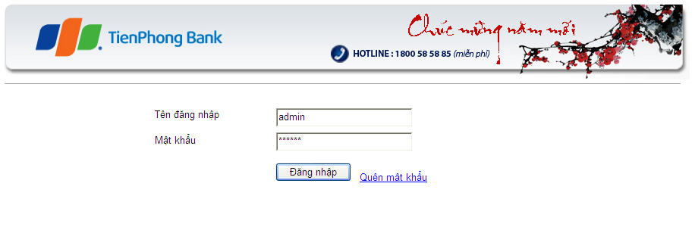

**Figure 1 - Login**

**Data field**

|  |  |  |  |
| --- | --- | --- | --- |
| No | Item | Type | Description |
|  |  |  |  |

## SC02: List users in a devision

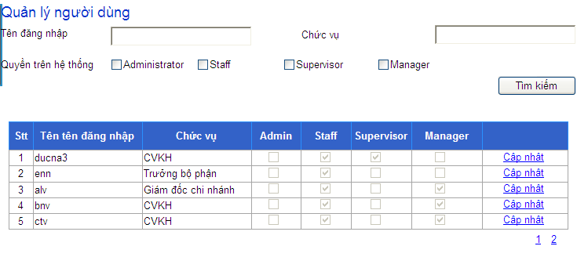

**Figure 2 – List users in a divison**

**Data field**

|  |  |  |  |
| --- | --- | --- | --- |
| No | Item | Type | Description |
|  |  |  |  |

## SC03: Search users

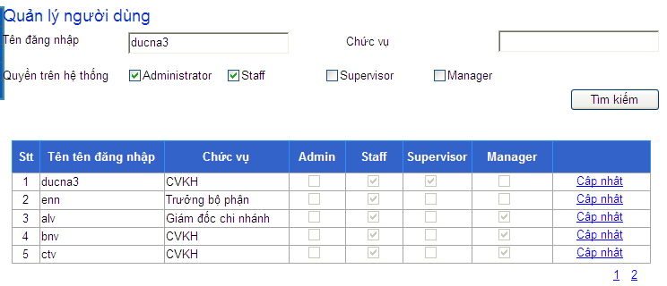

**Figure 3 – Search users**

**Data field**

|  |  |  |  |
| --- | --- | --- | --- |
| No | Item | Type | Description |
|  |  |  |  |

## SC04: View details user

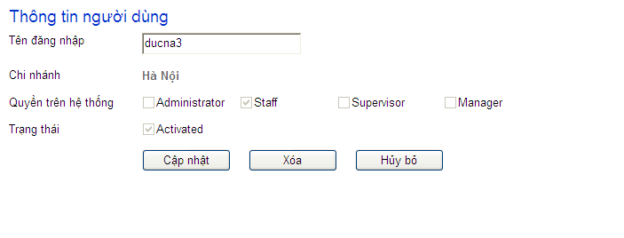

**Figure 4 - View details user**

**Data field**

|  |  |  |  |
| --- | --- | --- | --- |
| No | Item | Type | Description |
|  |  |  |  |

## SC05: Add new user

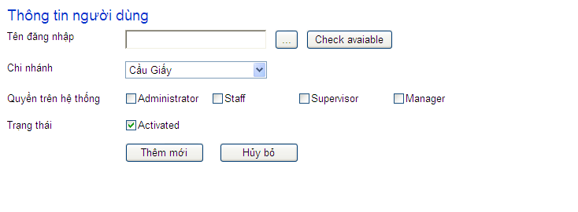

**Figure 5 – Add new user**

**Data field**

|  |  |  |  |
| --- | --- | --- | --- |
| No | Item | Type | Description |

## SC06: Edit user

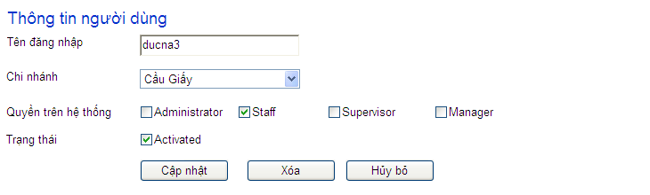

**Figure 6 – Edit user**

**Data field**

|  |  |  |  |
| --- | --- | --- | --- |
| No | Item | Type | Description |
|  |  |  |  |

## SC07: Delete user

**Figure 7 - Delete user**

**Data field**

|  |  |  |  |
| --- | --- | --- | --- |
| No | Item | Type | Description |
|  |  |  |  |

## SC08: List devisions

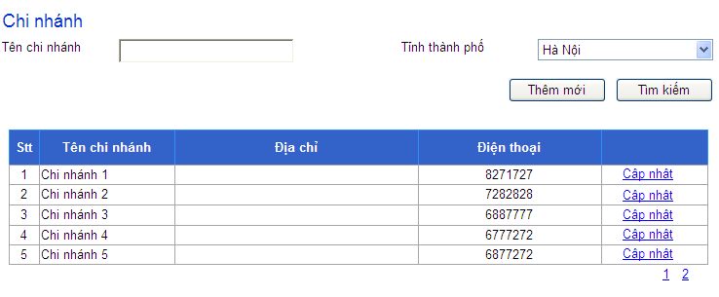

**Figure 8 – List devisions**

**Data field**

|  |  |  |  |
| --- | --- | --- | --- |
| No | Item | Type | Description |
|  |  |  |  |

## SC09: View detail devison

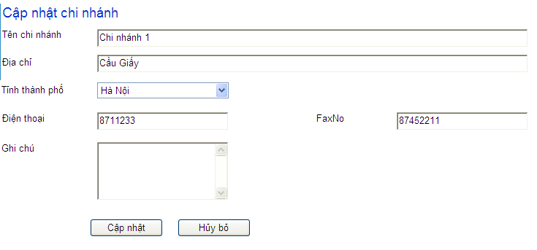

**Figure 9 – View detail devison**

**Data field**

The red strings indicate the users who can see this component

|  |  |  |  |
| --- | --- | --- | --- |
| No | Item | Type | Description |
|  |  |  |  |

## SC10: Add new devision

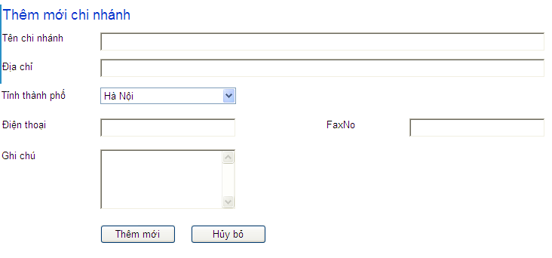

**Figure 10 – Add new devision**

**Data field**

|  |  |  |  |
| --- | --- | --- | --- |
| No | Item | Type | Description |
|  |  |  |  |

## SC11: Edit devision

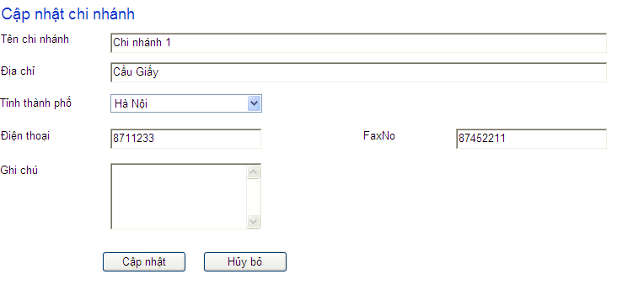

**Figure 11 – Edit devision**

**Data field**

|  |  |  |  |  |
| --- | --- | --- | --- | --- |
| No | Item | Type | | Description |
|  |  | |  |  |

## SC12: Delete devision

**Figure 12 – Delete devision**

**Data field**

|  |  |  |  |
| --- | --- | --- | --- |
| No | Item | Type | Description |
|  |  |  |  |

## SC13: Search customers

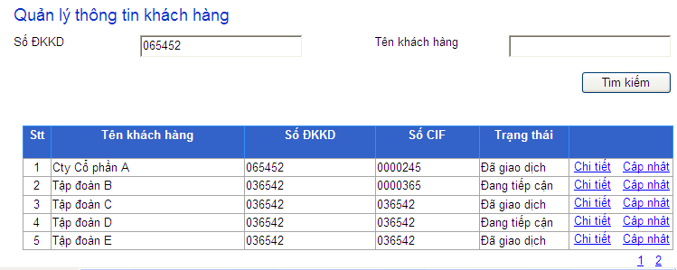

**Figure 13 – Search customers**

**Data field**

|  |  |  |  |
| --- | --- | --- | --- |
| No | Item | Type | Description |
|  |  |  |  |

## SC14: View detail customer

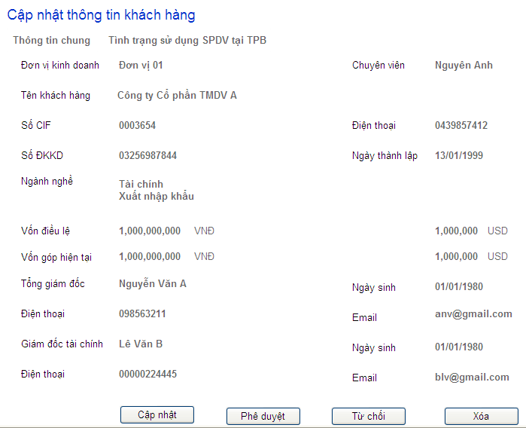

**Figure 14 – View detail customer**

**Data field**

|  |  |  |  |
| --- | --- | --- | --- |
| No | Item | Type | Description |
|  |  |  |  |

## SC15: View customer histories

**Figure 15 – View customer histories**

**Data field**

|  |  |  |  |
| --- | --- | --- | --- |
| No | Item | Type | Description |
|  |  |  |  |

## SC16: Add new customer

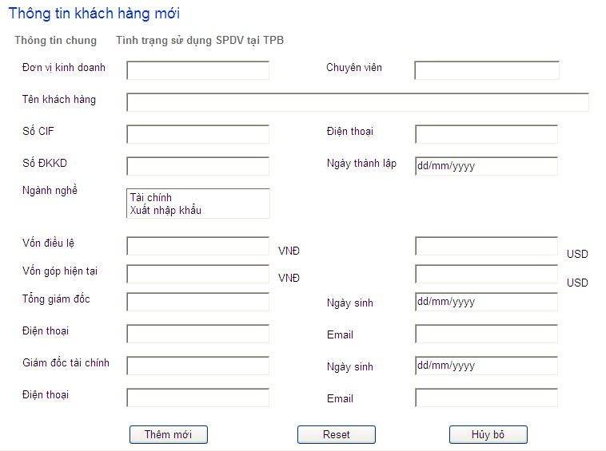

**Figure 16 – Add new customer**

**Data field**

|  |  |  |  |
| --- | --- | --- | --- |
| No | Item | Type | Description |
|  |  |  |  |

## SC17: Edit customer

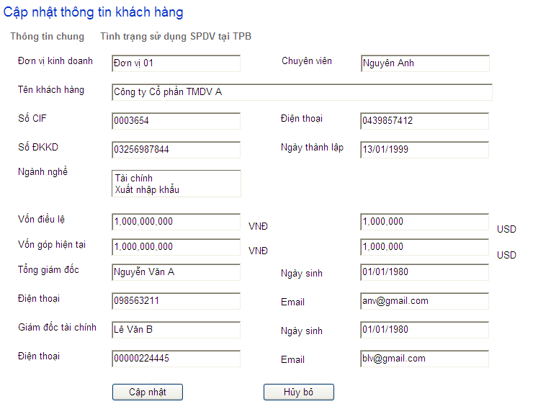

**Figure 17 – Edit customer**

**Data field**

|  |  |  |  |
| --- | --- | --- | --- |
| No | Item | Type | Description |
|  |  |  |  |
|  |  |  |  |
|  |  |  |  |
|  |  |  |  |
|  |  |  |  |
|  |  |  |  |
|  |  |  |  |

## SC18: Delete customer

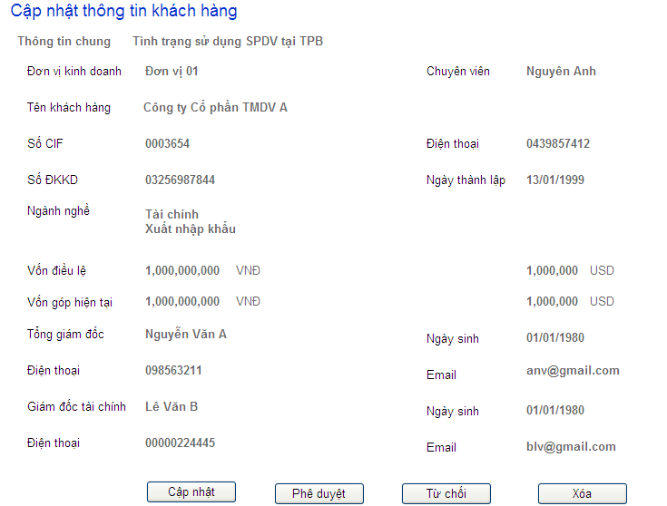

**Figure 18 – Delete customer**

**Data field**

|  |  |  |  |
| --- | --- | --- | --- |
| No | Item | Type | Description |
|  |  |  |  |

## SC19: List used services

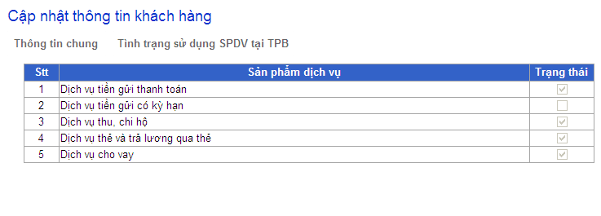

**Figure 19 – List used services**

**Data field**

|  |  |  |  |
| --- | --- | --- | --- |
| No | Item | Type | Description |
|  |  |  |  |

## SC20: Add new used services

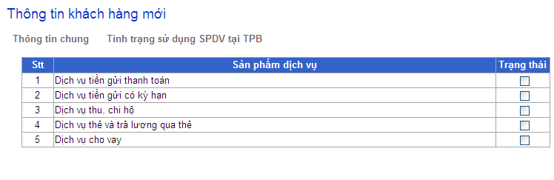

**Figure 20 – Add new used services**

**Data field**

|  |  |  |  |
| --- | --- | --- | --- |
| No | Item | Type | Description |
|  |  |  |  |

## SC21: Update used services

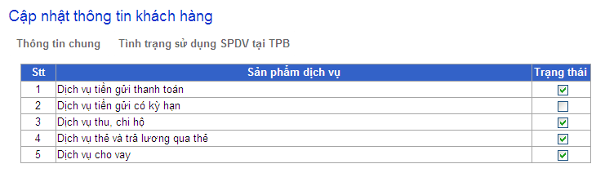

**Figure 21 – Update used services**

**Data field**

|  |  |  |  |
| --- | --- | --- | --- |
| No | Item | Type | Description |
|  |  |  |  |

## SC22: Approve change

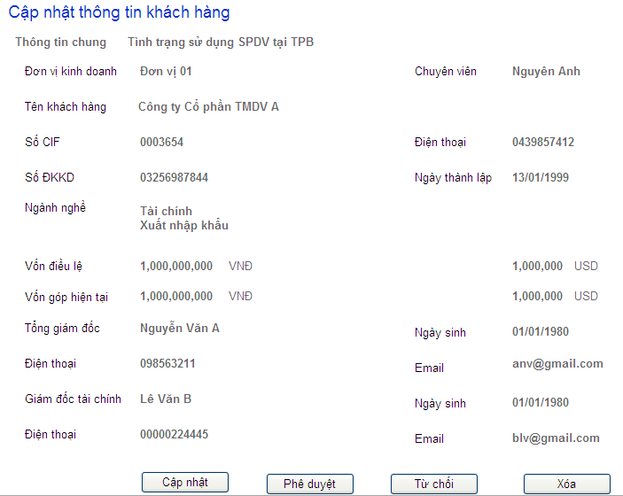

**Figure 22 – Approve change**

**Data field**

|  |  |  |  |
| --- | --- | --- | --- |
| No | Item | Type | Description |
|  |  |  |  |

## SC23: Nhập dữ liệu - Tình hinh SXLD

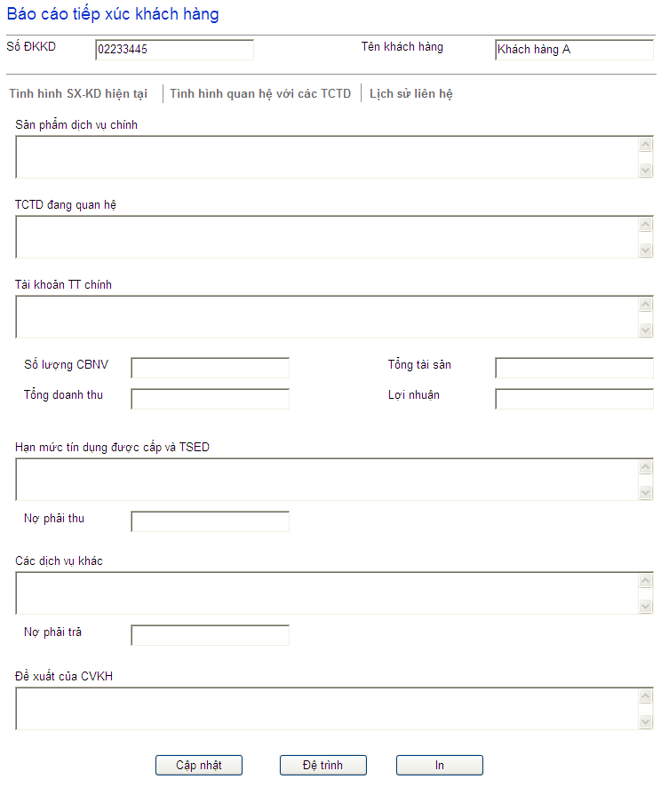

**Figure 23 - Nhập dữ liệu - Tình hinh SXLD**

**Data field**

|  |  |  |  |
| --- | --- | --- | --- |
| No | Item | Type | Description |
|  |  |  |  |

## SC24: Nhập dữ liệu – Quan hệ với các tổ chức tín dụng

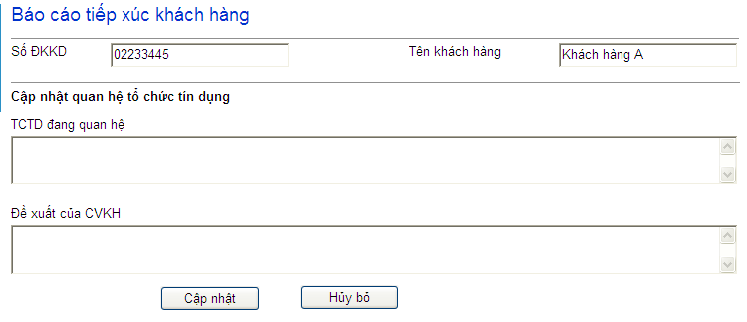

**Figure 24 – Nhập dữ liệu – Quan hệ với các tổ chức tín dụng**

**Data Field**

|  |  |  |  |
| --- | --- | --- | --- |
| No | Item | Type | Description |
|  |  |  |  |

## SC25: Nhập dữ liệu – Lịch sử tiếp xúc

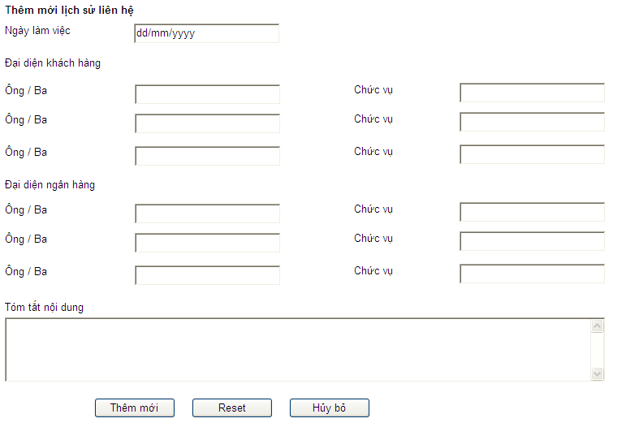

**Figure 25 – Nhập dữ liệu – Lịch sử tiếp xúc**

**Data field**

|  |  |  |  |
| --- | --- | --- | --- |
| No | Item | Type | Description |
|  |  |  |  |

## SC26: Edit dữ liệu - Tình hinh SXLD



**Figure 26 – Edit dữ liệu - Tình hinh SXLD**

**Data field**

|  |  |  |  |
| --- | --- | --- | --- |
| No | Item | Type | Description |
|  |  |  |  |

## SC27: Edit dữ liệu – Quan hệ với các tổ chức tín dụng

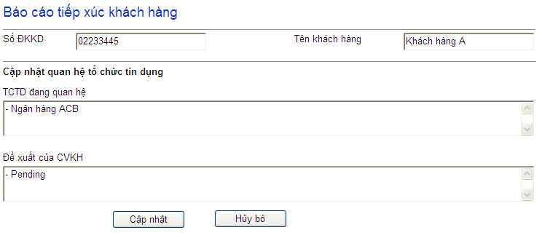

**Figure 27 – Edit dữ liệu – Quan hệ với các tổ chức tín dụng**

**Data field**

|  |  |  |  |
| --- | --- | --- | --- |
| No | Item | Type | Description |
|  |  |  |  |

## SC28: Edit dữ liệu – Lịch sử tiếp xúc

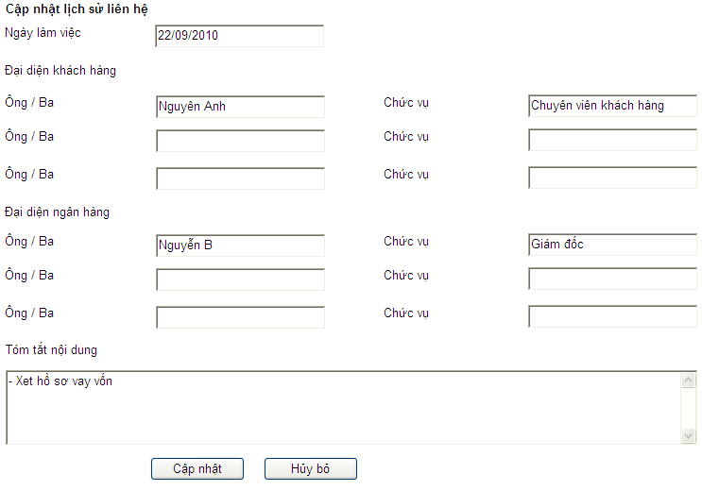

**Figure 28 - Edit dữ liệu – Lịch sử tiếp xúc**

**Data field**

|  |  |  |  |
| --- | --- | --- | --- |
| No | Item | Type | Description |
|  |  |  |  |

## SC29: Details View – Tình hình SXKD

**Figure 29 - Details View – Tình hình SXKD**

**Data field**

|  |  |  |  |
| --- | --- | --- | --- |
| No | Item | Type | Description |
|  |  |  |  |

## SC30: Details View – Quan hệ với các tổ chức tín dụng

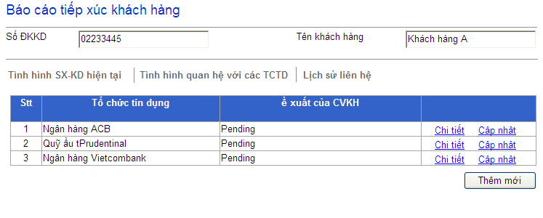

**Figure 30 - Details View – Quan hệ với các tổ chức tín dụng**

**Data field**

|  |  |  |  |
| --- | --- | --- | --- |
| No | Item | Type | Description |
|  |  |  |  |

## SC31: Details View – Lịch sử tiếp xúc

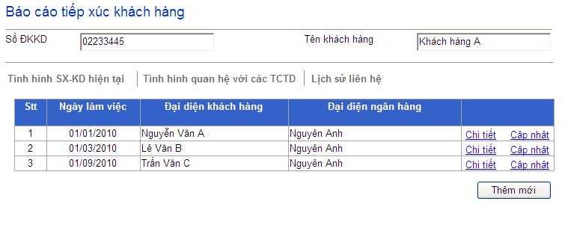

**Figure 31 – Details View – Lịch sử tiếp xúc**

**Data field**

|  |  |  |  |
| --- | --- | --- | --- |
| No | Item | Type | Description |
|  |  |  |  |

## SC32: Duyệt TXKH – Approve

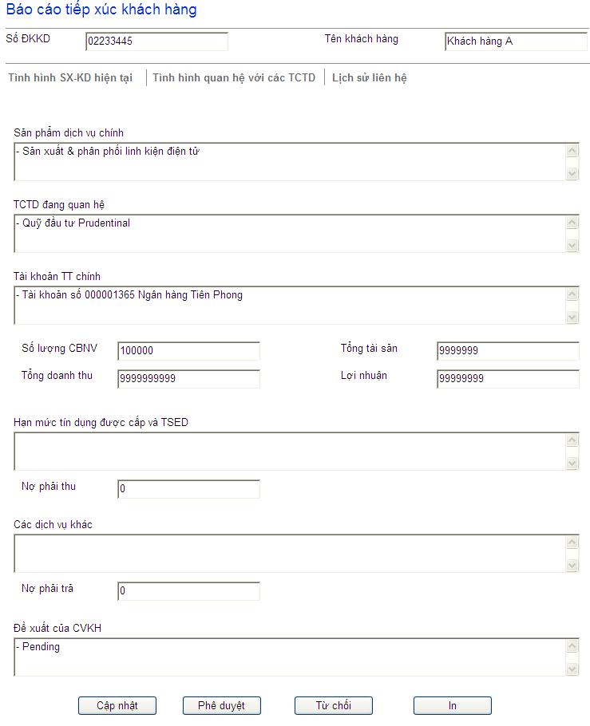

**Figure 32 – Duyệt TXKH – Approve**

**Data field**

|  |  |  |  |
| --- | --- | --- | --- |
| No | Item | Type | Description |
|  |  |  |  |

## SC33: Duyệt TXKH – Reject



**Figure 33 – Duyệt TXKH – Reject**

**Data field**

|  |  |  |  |
| --- | --- | --- | --- |
| No | Item | Type | Description |
|  |  |  |  |



## SC34: Duyệt TXKH – Cancel



**Figure 33 – Duyệt TXKH – Cancel**

**Data field**

|  |  |  |  |
| --- | --- | --- | --- |
| No | Item | Type | Description |
|  |  |  |  |

## SC35: Xóa – Quan hệ với các tổ chức tín dụng

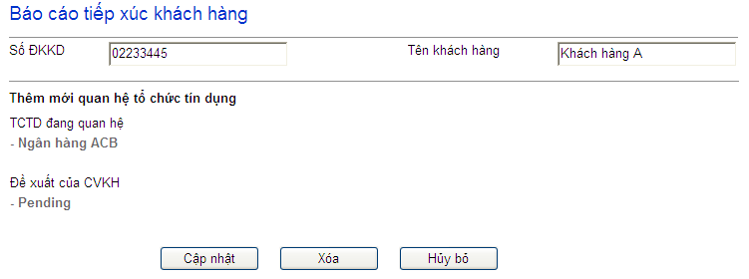

**Figure 35: Xóa – Quan hệ với các tổ chức tín dụng**

**Data field**

|  |  |  |  |
| --- | --- | --- | --- |
| No | Item | Type | Description |
|  |  |  |  |

## SC36: Xóa – Lịch sử tiếp xúc

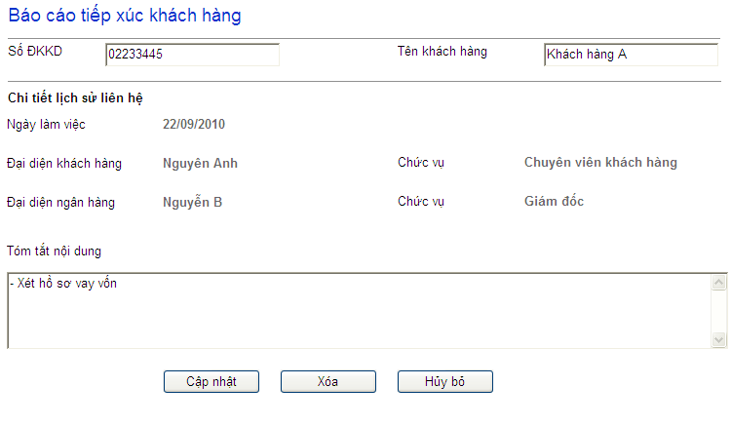

**Figure 36 – Xóa – Lịch sử tiếp xúc**

**Data field**

|  |  |  |  |
| --- | --- | --- | --- |
| No | Item | Type | Description |
|  |  |  |  |

## SC37: Báo cáo theo CIF

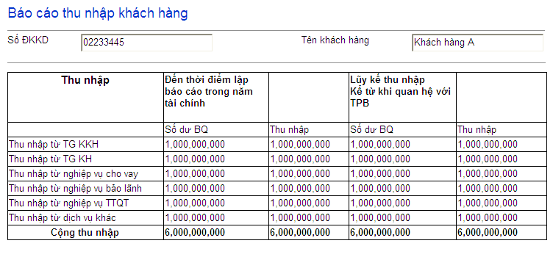

**Figure 37 – Báo cáo theo CIF**

**Data field**

|  |  |  |  |
| --- | --- | --- | --- |
| No | Item | Type | Description |
|  |  |  |  |

## SC38: Báo cáo theo ĐVKD

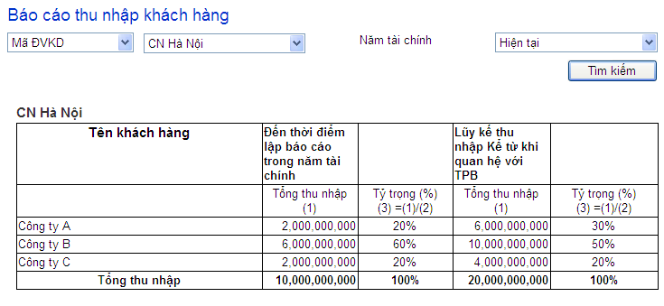

**Figure 38 – Báo cáo theo ĐVKD**

**Data field**

|  |  |  |  |
| --- | --- | --- | --- |
| No | Item | Type | Description |
|  |  |  |  |

## SC39: Báo cáo toàn bank

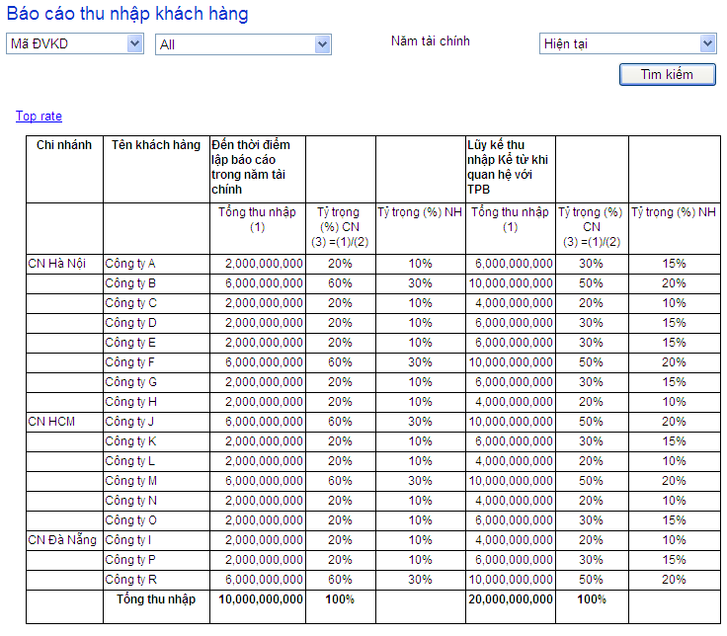

**Figure 39 – Báo cáo toàn bank**

**Data field**

|  |  |  |  |
| --- | --- | --- | --- |
| No | Item | Type | Description |
|  |  |  |  |

## SC40:

# Nonfunctional Requirements

* 1. Accessibility

This subsection specifies the following requirements associated with the degree to which the system must be accessible to people with disabilities:

* ACC-1) Any graphical user interfaces of the CRM shall be usable by persons with color blindness.
* ACC-2) Any graphical user interfaces of the CRM shall use an adequate font size to be usable by persons with limited visual acuity.
  1. Audit-ability

This subsection specifies the following requirements associated with the degree to which the system must support independent auditing of its events CRUD at database:

* AUD-1) The CRM shall maintain a record for each insert/update/delete action:
* Authenticated user
* Time
* IP address of client
  1. Correctness
     1. Accuracy

This subsection specifies the following requirements concerning the degree of correctness of the system’s outputs:

* COR-1) Values of money shall be correct to the nearest “dong”.
* COR-2) Values of time shall be correct to the nearest second.
  + 1. Precision

This subsection specifies the following requirements concerning the degree of correctness of the system’s outputs:

* COR-3) Values of money shall be correct to the nearest “dong”.
* COR-4) Values of time shall be correct to the nearest second.
  1. Interoperability

This subsection specifies the following requirements associated with the ease with which the system can be integrated with other system (e.g., browsers, legacy applications, and required databases).

* The CMR shall interoperate with the following browsers:
* IOP-1) Internet Explorer 11
* IOP-2) Google Chrome 34
* IOP-2) Mozilla Firefox 12
  1. Maintainability

This subsection specifies the following requirements associated with the ease with which the system can be maintained:

* M-1) The CRM shall permit the swapping and upgrade of hardware without down time.
* M-2) The CRM shall permit the upgrade of software without down time.
* M-3) The Mean Time To Fix (MTTF) shall not exceed one person day.
  1. Performance

This subsection specifies the following requirements associated with the speed with which the system shall function.

* + 1. Capacity

This subsection specifies the following requirements concerning the minimum number of objects that the system can support:

* PER-1) The system shall support a minimum of 100 employees.
* PER-2) The system shall support a minimum of 10,000 users.
* PER-3) The system shall support a minimum of 10,000 simultaneous interactions.
  + 1. Response Time

This subsection specifies the following requirements concerning the maximum time that is permitted for the system to respond to requests:

* PER-4) All system responses shall occur within 10 seconds.
  + 1. Throughput

This subsection specifies the following requirements concerning how many executions of a given system operation or use case path must the system be able execute in a unit of time:

* TBD
  1. Portability

This subsection specifies the following requirements associated with the ease with which the system can be moved from one environment (e.g., hardware, operating system) to another.

* The CRM shall enable users to use the following environments (e.g., platform and operating system) to interact with The CRM:
* User Personal Computer:

POR-1) PC with minimum of Celeron chip, 2 GBs of RAM, and a 256 kbps ADSL modem

* Operating Systems:

POR-2) Windows 7

POR-3) Fedora Linux 16

POR-4) Ubuntu 14

* 1. Reliability

This subsection specifies the following requirements associated with the reliability (e.g., mean time between failures, number of failures per unit time) of the system.

* REL-1) The mean time between failures (MTBF) shall exceed 3 months.
  1. Reusability

This subsection specifies the following requirements associated with the degree to which the system can be used for purposes other than originally intended (e.g., as part of other applications).

* REU-1) The CRM shall incorporate a database continuous availability layer.
* REU-2) The CRM shall reuse common classes such as name, address, telephone number, and currency.
* REU-3) The CRM shall reuse software for sending emails.
  1. Robustness

This subsection specifies the following requirements associated with the degree to which the system continues to properly function under abnormal circumstances.

* ROB-1) The CRM should gracefully handle invalid input (i.e., detect invalid input, request valid input, and not crash) from all externals:
* The human actors.
* The Authorization Processor Gateway.
* ROB-2) The CRM should gracefully handle hardware failures (i.e. provide hot failover, notify the system operator, and not crash).
  1. Safety

This subsection specifies the following requirements associated with the degree to which the system does not directly or indirectly (e.g., via inactivity) cause accidental harm to life or property (e.g., loss of money or data).

* SAF-1) The CRM shall not accidentally lose user account information.

# System Constraints

The section documents the major architecture, design, and implementation constraints on the system.

* 1. Business Rules

The subsection documents all required data design constraints.

* 1. Data and Content Constraints

The subsection documents all required data constraints.

* + 1. Databases

The subsection documents all required design constraints regarding the use of databases.

* None
  1. Hardware Constraints

The subsection documents all required constraints associated with minimum or actual hardware.

* None
  1. Software Constraints

The subsection documents all required software constraints.

* + 1. High-Level Languages

The subsection documents all required design constraints associated with the use of high-level programming languages.

* SYSDC-HLL-1) Application server software shall be written in Java.
* SYSDC-HLL-2) Employee client software shall be written in Java.
* SYSDC-HLL-3) User client software shall be written in DHTML, CSS, and JavaScript webpages.
* SYSDC-HLL-4) Where practical, data shall be defined and documented using XML.
  1. Industry Standards

The subsection documents all required design constraints associated with industry standards.

DC-STD-1) The system shall conform to ISO 10646 (Unicode UTF-8) and ISO 10646-1 (Unicode UTF-16) standards for character set encoding.

* [www.unicode.org](http://www.unicode.org)
* [ftp.informatik.uni-erlangen.de/pub/doc/ISO/charsets/ISO-10646-UTF-8.html](ftp://ftp.informatik.uni-erlangen.de/pub/doc/ISO/charsets/ISO-10646-UTF-8.html)
* [ftp.informatik.uni-erlangen.de/pub/doc/ISO/charsets/ISO-10646-UTF-16.html](ftp://ftp.informatik.uni-erlangen.de/pub/doc/ISO/charsets/ISO-10646-UTF-16.html)

DC-STD-2) The system shall conform to ISO 4217, codes for the representation of currencies.

* [www.xe.net/gen/iso4217.htm](http://www.xe.net/gen/iso4217.htm)

DC-STD-3) The system shall conform to ISO 31, codes for units of measure.

* [www.unece.org/trade/rec/rec20en.htm](http://www.unece.org/trade/rec/rec20en.htm)

DC-STD-4) The system shall conform to ISO639-1 Languages, codes for the representation of languages.

* <http://sunsite.berkeley.edu/amher/iso_639.html>

DC-STD-5) The system shall conform to ISO 3166-1, codes for the representation of names of countries.

* [www.din.de/gremien/nas/nabd/iso3166ma/codlstp1/index.html](http://www.din.de/gremien/nas/nabd/iso3166ma/codlstp1/index.html)

DC-STD-6) The system shall conform to ISO 8601, representation of dates and times.

* [www.state.ak.us/local/akpages/ADMIN/info/iso8601.htm](http://www.state.ak.us/local/akpages/ADMIN/info/iso8601.htm)
  1. Legal and Regulatory Constraints

The subsection documents all required design constraints associated with legal and regulatory constraints.

* None

# Appendices

This section documents the following appendices:

* Envisioned Future Enhancements
* Open Issues
* Major TBDs
* Assumptions

## A. Envisioned Future Enhancements

TBD

## B. Open Issues

TBD

## C. Major TBDs

This appendix documents the following major TBDs:

* Add correctness requirements.
* Interface of external systems: eHTi

## D. Assumptions

TBD